**FARMER MANAGEMENT SYSTEM**

21CSC205P Database Management Systems

MINI PROJECT REPORT

*Submitted by*

**P. SAI RAMESH[RA2311028010045]**

**V. VENKATA KAMAL SAI[RA2311028010055]**

*Under the Guidance of*

**Dr. P. MAHALAKSHMI**

Assistant Professor, Department of Networking and Communications

*in partial fulfillment of the requirements for the degree of*,

BACHELOR OF TECHNOLOGY

in

COMPUTER SCIENCE AND ENGINEERING

with specialization in CLOUD COMPUTING

DEPARTMENT OF NETWORKING AND COMMUNICATIONS

COLLEGE OF ENGINEERING AND TECHNOLOGY

SRM INSTITUTE OF SCIENCE ANDTECHNOLOGY

KATTANKULATHUR- 603 203

MAY 2025

**SRM INSTITUTE OF SCIENCE**

**AND TECHNOLOGY**

**KATTANKULATHUR – 603 203**

**BONAFIDE CERTIFICATE**

Certified that Project report titled “**FARMER MANAGEMENT SYSTEM**” is the bonafide work of “**PRAGADA SAI RAMESH [RA2311028010045], V. VENKATA KAMAL SAI [RA2311028010055]”** who carried out the **21CSC205P Database Management Systems** mini project work under my supervision.

**Dr. P.MAHALAKSHMI Dr. M. LAKSHMI**

**COURSE FACULTY PROFESSOR & HEAD**

Associate Professor Department of

Department Of Networking And

Networking And Communications

Communications



**ABSTRACT**

Agriculture continues to be the backbone of rural economies, yet many farmers still face serious challenges when it comes to marketing their produce, reaching potential buyers, and earning fair returns for their hard work. In a world that’s rapidly moving online, these gaps in access and opportunity can leave rural farmers behind. Agri-Market, a farmer-friendly digital platform, was developed to bridge this gap by bringing agricultural commerce into the digital age.

Agri-Market is an online system that allows farmers to list and sell their products such as crops, fertilizers, and farm machinery directly to customers. The platform empowers farmers by giving them more control over pricing, visibility, and sales, eliminating the need for intermediaries. At the same time, customers benefit from direct access to quality products at fair prices. It’s a win-win for both sides.

The system provides separate, easy-to-use interfaces for farmers and customers. Farmers can register, add their product listings, track sales, and manage their stock. Customers can browse through available items, place orders, and receive clear billing information. The platform also manages important background operations like order tracking, inventory updates, and secure data storage making the entire process smooth and reliable.

Some key highlights of the platform include:

* Farmer and customer registration with login access
* Product listing sections for crops, fertilizers, and machinery
* Order management and automated billing
* Live inventory updates after every sale
* Simple dashboard experience for both users

Beyond just transactions, Agri-Market promotes trust, transparency, and technology adoption in rural communities. It opens new doors for farmers who may have never used digital tools before and gives them a wider customer base beyond their villages or towns. The system also ensures that customers, whether in urban or rural areas, get fresh, locally sourced products directly from the producers.

In conclusion, Agri-Market is more than a technical solution; it’s a meaningful step toward transforming how agriculture works at the grassroots level. By supporting farmers and building direct links between producers and consumers, this platform helps improve rural livelihoods and encourages sustainable agricultural growth in a modern, tech-enabled way.

**PROBLEM STATEMENT**

In many parts of the world—especially in rural and agricultural regions farmers face significant challenges when it comes to selling their produce and reaching the right buyers. Despite working hard to grow crops and manage their farms, most small and medium-scale farmers struggle to get fair prices for their products. The main reason behind this is the lack of a direct connection between farmers and customers.

Traditionally, agricultural goods pass through multiple middlemen before reaching the end consumer. Each link in this chain adds extra cost, reduces the farmer’s profit, and often leads to delays or even product wastage. Farmers are also forced to sell their goods at lower rates due to the absence of real-time market information or alternative selling options. On the other hand, customers especially those in urban areas often pay high prices for products that are neither fresh nor sourced ethically.

Adding to the problem is the limited access to digital tools among rural communities. While technology has transformed many industries, the agricultural sector particularly at the grassroots level remains under-served. Many farmers lack the digital platforms and systems needed to manage their inventories, promote their products, or communicate directly with customers. Similarly, customers have no simple or reliable way to purchase farm products directly from producers.

There is also a lack of transparency in transactions. Neither party has full visibility into pricing, quality, or billing details. Paper records or informal agreements often lead to disputes, errors, and a lack of trust.

To solve these pressing issues, there is a need for a digital system that connects farmers and customers in a transparent, user-friendly, and efficient manner. Such a system should allow farmers to register, list their products, manage orders, and track inventory, while enabling customers to browse, place orders, and receive accurate billing all without the need for third-party interference.

Agri-Market aims to fill this gap by creating a digital bridge between farmers and customers. It removes the barriers of location, information, and accessibility by offering a platform where both parties can interact directly, trade fairly, and build long-term trust. The goal is not just to improve sales or simplify transactions, but to empower farmers, strengthen rural economies, and modernize the agricultural supply chain in a meaningful and sustainable way.

# **TABLE OF CONTENTS**

|  |  |  |
| --- | --- | --- |
| **Chapter No** | **Chapter Name** | **Page No** |
|  | Problem understanding, Identification of Entity and Relationships, Construction of DB using ER Model for the project | **6** |
|  | Design of Relational Schemas, Creation of Database Tables for the project. | **9** |
|  | Complex queries based on the concepts of constraints, sets, joins, views, Triggers and Cursors. | **19** |
|  | Analyzing the pitfalls, identifying the dependencies, and applying normalizations | **32** |
|  | Implementation of concurrency control and recovery mechanisms | **35** |
| **6.** | Result and Discussion (Screen shots of the implementation with front end). | **44** |
| **7.** | Attach the Real Time project certificate / Online course certificate | **55** |

**1.Problem understanding, Identification of Entity and Relationships, Construction of DB using ER Model for the project**

**1.1 Problem Understanding**

Agriculture plays a key role in feeding the world, but farmers often struggle to get fair prices for their produce. Middlemen dominate the supply chain, and farmers don’t always have access to the best markets or technology to optimize their sales. This leads to inefficiencies, lower income for farmers, and sometimes higher prices for consumers.

Our solution, Agri-Market, aims to bridge this gap by providing a digital platform where farmers can sell their products directly to customers. This way, farmers get better prices, customers get fresh produce, and the whole process becomes more transparent and efficient.

**1.2 Identifying Entities and Attributes**

**Farmer:** Stores information about farmers who sell crops on the platform.

**Customer:** Stores information about customers who buy crops, machinery, or fertilizers.

**Crop:** Represents crops available for sale, including their names and quantities.

**Sell Crop:** Connects farmers with the crops they are selling and includes pricing.

**Machinery:** Contains details about farming machinery available for sale.

**Fertilizer:** Stores details about fertilizers and their components.

**Crop Transaction:** Records purchases of crops made by customers from specific farmers.

**Machinery Transaction:** Records purchases of machinery by customers.

**Fertilizer Transaction:** Tracks fertilizer purchases made by customers.

**Billing:** Manages payment and billing details for transactions made by customers.

**Farmer**

* Farmer ID (Primary Key)
* Farmer name
* Mobile no
* Email ID
* City
* Password

**Customer**

* Customer ID (Primary Key)
* Customer name
* Mobile no
* Email ID
* City
* Password

**Crop**

* Crop ID (Primary Key)
* Crop name
* Quantity in kgs

**Sell Crop**

* Crop ID + Farmer ID (Composite Primary Key)
* Crop ID (Foreign Key → Crop)
* Farmer ID (Foreign Key → Farmer)
* Price

**Machinery**

* Machine ID (Primary Key)
* Machine name
* Company
* Price

**Fertilizer**

* Fertilizer ID (Primary Key)
* Fertilizer name
* Component
* Price

**Crop Transaction**

* Trans ID (Primary Key)
* Customer ID (Foreign Key → Customer)
* Crop ID (Foreign Key → Crop)
* Farmer ID (Foreign Key → Farmer)

**Machinery Transaction**

* Trans ID (Primary Key)
* Machine ID (Foreign Key → Machinery)
* Customer ID (Foreign Key → Customer)

**Fertilizer Transaction**

* Trans ID (Primary Key)
* Fertilizer ID (Foreign Key → Fertilizer)
* Customer ID (Foreign Key → Customer)

**Billing**

* Bill ID (Primary Key)
* Customer ID (Foreign Key → Customer)
* Amount
* Card no
* Card name
* Expiry
* CVV

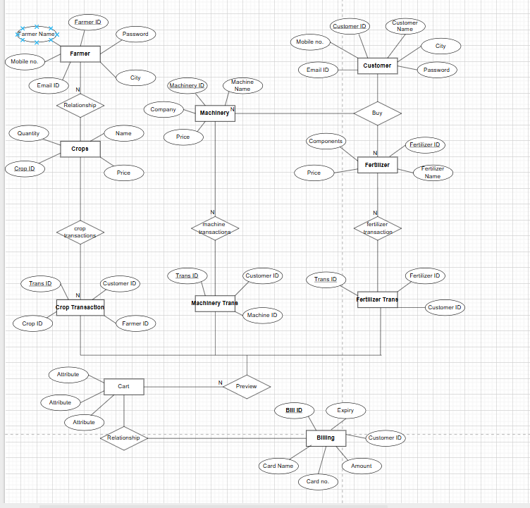**1.3-1 ENTITY-RELATIONSHIP ( ER ) DIAGRAM**

**2.Design of Relational Schemas, Creation of Database Tables for the project**

**2.1 Schema Diagram**

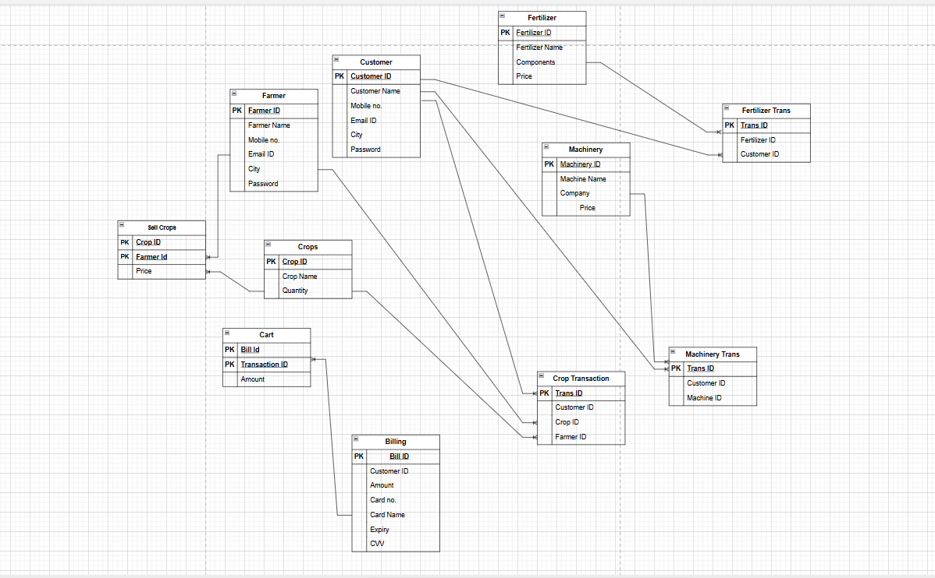

**2.2 Creation of Database Tables**

1. **Farmer Table**

CREATE TABLE Farmer(

Farmer_ID VARCHAR(7),

Farmer_name VARCHAR(20) NOT NULL,

Mobile_no NUMERIC(10,0),

Email_ID VARCHAR(20),

City VARCHAR(10),

Password VARCHAR(20),

PRIMARY KEY (Farmer_ID));

**Inserting the Values into Table**

insert into Farmer(Farmer_ID, Farmer_name ,Mobile_no, Email_ID, City, Password) values

('222123', 'Mukesh Gandhi', 7638267981, 'mukeshg@gmail.com','Raigarh', 'abcd'),

('222124', 'Harsh Sodhi', 9274861963, 'harsh122@gmail.com', 'Mumbai', 'xyzq'),

('222125', 'Rajaram Patil', 8888998907, 'rajpatil@gmail.com', 'Pune', 'qwer'),

('222126', 'Pravin Zade', 9274868883, 'pzade@gmail.com', 'Sangli', 'tyui'),

('222127', 'Shivaji Patil', 9272345323, 'shivajip@gmail.com', 'Nagpur', 'opas'),

('222128', 'Ajay Wagh', 9727116783, 'ajaywagh@gmail.com', 'Satara', 'dfgh'),

('222129', 'Prakash Pawar', 7774861113, 'prakashp@gmail.com', 'Sangli', 'jklp'),

('222130', 'Nikhil Jadhav', 8274861963, 'nikhilj@gmail.com', 'Nashik', 'cdcd'),

('222131', 'Anil Satpute', 8274861963, 'anils@gmail.com', 'Nagar', 'cdio');

**To Display**

SELECT *FROM Farmer;

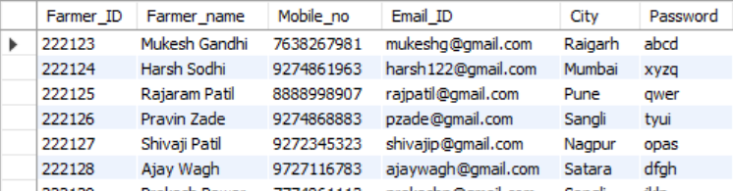

1. **Customer**

CREATE TABLE Customer(

Customer_ID VARCHAR(7),

Customer_name VARCHAR(20) NOT NULL,

Mobile_no NUMERIC(10,0),

Email_ID VARCHAR(20),

City VARCHAR(10),

Password VARCHAR(20),

PRIMARY KEY (Customer_ID));

**Inserting the Values into Table**

insert into Customer(customer_ID,Customer_name,mobile_no,email_ID,city,password)values

('111351', 'Kushal Preet', 7652801946, 'kushalp@hotmail.com', 'Bhopal', 'pqrs'),

('111352', 'Rohanpreet Singh', 8972801946, 'rohanpr@gmail.com', 'Chandigarh', 'pqos'),

('111353', 'Anup Gandhi', 7630967981, 'anpg@gmail.com', 'Raigarh’, 'abod'),

('111354', 'Harsh Jadhav', 9274877783, 'harsh@gmail.com', 'Mumbai', 'xpzq'),

('111355', 'Rajaram Patil', 8844998907, 'rajpatil@gmail.com', 'Pune', 'qwer'),

('111356', 'Pradip Darade', 9990856583, 'pdarade@gmail.com', 'Sangli', 'yyui'),

('111357', 'Santosh Ubale', 8902345323, 'santoshub@gmail.com', 'Nagpur', 'oras'),

('111358', 'Babanrao Wagh', 9727119083, 'bwagh@gmail.com', 'Satara', 'yuio'),

('111359', 'Madhavrao Pawar', 7774866113, 'madhavp@gmail.com', 'Kolhapur', 'jklp'),

('111360', 'Satish More', 8884861963, 'satishm@gmail.com’, 'Nashik''idcd'),

('111361', 'Anil Arote', 8274898963, 'aarote@gmail.com', 'Nagar', 'cdit'),

('111362', 'Kapil Verma', 9932201207, 'kapilv@hotmail.com', 'Hyderabad', 'rsuv');

**To Display**

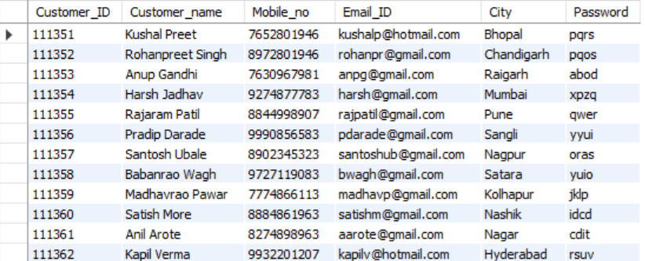SELECT *FROM Customer;

1. **Crop Table**

CREATE TABLE Crop(

Crop_ID VARCHAR(7),

Crop_name VARCHAR(20) NOT NULL,

Quantity_in_kgs NUMERIC(4,2),

PRIMARY KEY (Crop_ID));

**Inserting the Values into Table**

insert into Crop(Crop_ID, Crop_name, Quantity_in_kgs)values

('333411', 'Wheat', 25),

('333412', 'Rice', 30),

('333413', 'Bajra', 25),

('333414', 'Jawar', 25),

('333415', 'Masoor dal', 35),

('333416', 'Urad dal, 40),

('333417', 'Tur dal', 45),

('333418', 'Mung dal', 30),

('333419', 'Urad dal', 25),

('333420', 'Soyabean', 30);

**To Display**

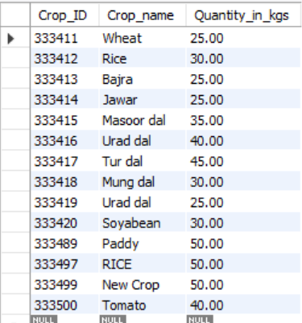SELECT *FROM Crop;

1. **Sell crop Table**

CREATE TABLE sell_crop(

Crop_ID VARCHAR(7),

Farmer_ID VARCHAR(7),

Price NUMERIC(5,2),

PRIMARY KEY (Crop_ID, Farmer_ID),

FOREIGN KEY (Crop_ID) REFERENCES Crop(Crop_ID) ON DELETE CASCADE,

FOREIGN KEY (Farmer_ID) REFERENCES Farmer(Farmer_ID) ON DELETE CASCADE);

**Inserting the Values into Table**

insert into sell_crop(Crop_ID, Farmer_ID, Price) values

('333411', '222123', 100),

('333412', '222124', 120),

('333413', '222126', 80),

('333414', '222127', 90),

('333415', '222130', 100),

('333419', '222128', 70);

**To Display**

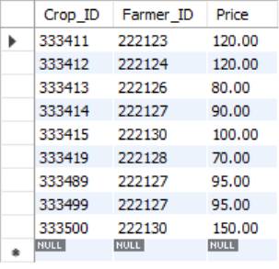SELECT *FROM sell_crop;

1. **Machinery Table**

CREATE TABLE Machinery(

Machine_ID VARCHAR(7),

Machine_name VARCHAR(10),

Company VARCHAR(15),

Price NUMERIC(7,2),

PRIMARY KEY (Machine_ID));

**Inserting the Values into Table**

insert into Machinery (machine_ID, Machine_name, company, Price) values

('444550', 'Tractor', 'jbl_motors', 2500),

('444551', 'Plough', 'Tata_motors', 5500),

('444552', 'Baler', 'jbl_motors', 4500),

('444553', 'Planter', 'Tata_motors', 3500),

('444554', 'Harrows', 'jbl_motors', 9500),

('444555', 'Sickle', 'Nandan_machines', 1000);

**To Display**

SELECT *FROM Machinery;

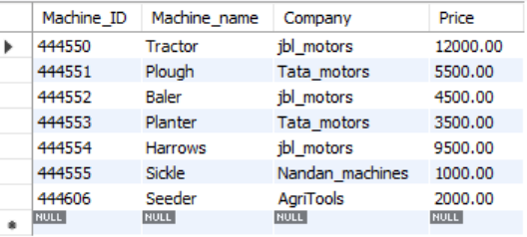

1. **Fertilizer Table**

CREATE TABLE Fertilizer(

Fertilizer_ID VARCHAR(7),

Fertilizer_name VARCHAR(20) NOT NULL,

Component VARCHAR(10),

Price NUMERIC(7,2),

PRIMARY KEY (Fertilizer_ID));

**Inserting the Values into Table**

insert into Fertilizer(Fertilizer_ID,Fertilizer_name,Component, Price)values

('666123', 'Urea', 'Nitrogen', 2300),

('666124', 'Ammonium Nitrate', 'Nitrogen', 4300),

('666125', 'Ammonium Sulfate', 'Sulphur', 3300),

('666126', 'Calcium Nitrate', 'Calcium', 3400),

('666127', 'Potassium Chloride', 'Potassium', 2200),

('666128', 'Potassium Nitrate', 'Nitrogen', 1200);

**To Display**

SELECT *FROM Fertilizer;

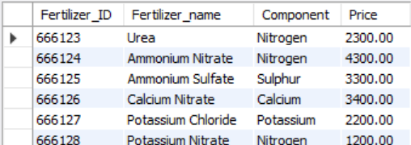

1. **Crop transaction Table**

CREATE TABLE crop_transaction(

trans_IDc VARCHAR(7),

Customer_ID VARCHAR(7),

Crop_ID VARCHAR(7),

Farmer_ID VARCHAR(7),

PRIMARY KEY (trans_IDc),

FOREIGN KEY (Customer_ID) REFERENCES Customer(Customer_ID) ON DELETE CASCADE,

FOREIGN KEY (Crop_ID) REFERENCES Crop(Crop_ID) ON DELETE CASCADE,

FOREIGN KEY (Farmer_ID) REFERENCES Farmer(Farmer_ID) ON DELETE CASCADE);

**Inserting the Values into Table**

insert into crop_transaction(trans_IDc, Customer_ID, Crop_ID, Farmer_ID) values

('555100', '111351', '333411', '222123'),

('555101', '111352', '333412', '222124'),

('555102', '111354', '333413', '222126'),

('555103', '111355', '333414', '222127'),

('555104', '111360', '333419', '222128');

**To Display**

SELECT *FROM crop_transaction;

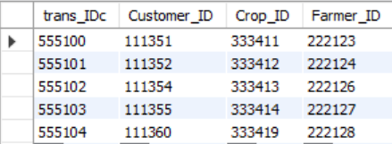

1. **Machinery transaction Table**

CREATE TABLE machinery_transaction(

trans_IDm VARCHAR(7),

Machine_ID VARCHAR(7),

Customer_ID VARCHAR(7),

PRIMARY KEY (trans_IDm),

FOREIGN KEY(Machine_ID) REFERENCES Machinery(Machine_ID) ON DELETE CASCADE,

FOREIGN KEY(Customer_ID) REFERENCES Customer(Customer_ID) ON DELETE CASCADE);

**Inserting the Values into Table**

insert into machinery_transaction(trans_IDm, Machine_ID, Customer_ID)values

('555200', '444550', '111351'),

('555201', '444551', '111353'),

('555202', '444553', '111354'),

('555203', '444554', '111356'),

('555204', '444555', '111360');

**To Display**

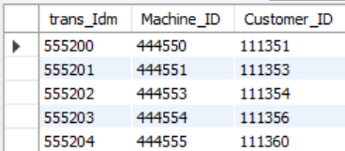SELECT *FROM machinery_transaction;

1. **Fertilizer transaction**

CREATE TABLE fertilizer_transaction(

trans_IDf VARCHAR(7),

Fertilizer_ID VARCHAR(7),

Customer_ID VARCHAR(7),

PRIMARY KEY (trans_IDf),

FOREIGN KEY (Fertilizer_ID) REFERENCES Fertilizer(Fertilizer_ID) ON DELETE CASCADE,

FOREIGN KEY(Customer_ID) REFERENCES Customer(Customer_ID) ON DELETE CASCADE);

**Inserting the Values into Table**

insert into fertilizer_transaction(trans_IDf, Fertilizer_ID, Customer_ID) values

('555301', '666123', '111357'),

('555302', '666125', '111358'),

('555303', '666126', '111359'),

('555304', '666128', '111360'),

('555305', '666124', '111361');

**To Display**

SELECT * FROM fertilizer_transaction;

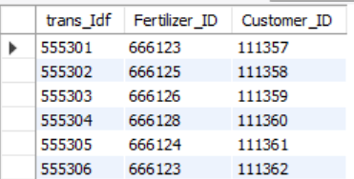

1. **Billing Table**

CREATE TABLE billing(

bill_ID VARCHAR(7),

Customer_ID VARCHAR(7),

Amount NUMERIC(7,2),

Card_no INT,

Card_name VARCHAR(20),

Expiry INT,

CVV NUMERIC(3,0),

PRIMARY KEY(bill_ID),

FOREIGN KEY(Customer_ID) REFERENCES Customer(Customer_ID) ON DELETE CASCADE);

**Inserting the Values into Table**

insert into billing(bill_ID, Customer_ID, amount, card_no, card_name, expiry, CVV)values

('999901', '111351', 2600, 89, 'ABC', 2022, 111),

('999902', '111352', 120, 12, 'DEF', 2021, 222),

('999903', '111353', 5500, 60, 'XYZ', 2023, 333),

('999904', '111354', 3580, 75, 'MNO', 2024, 444),

('999905', '111355', 90, 35, 'PQR', 2025, 555),

('999906', '111356', 9500, 48, 'JKL', 2023, 666),

('999907', '111357', 2300, 36, 'BCD', 2022, 777),

('999908', '111358', 3300, 24, 'UVW', 2023, 888),

('999909', '111359', 3400, 99, 'EFG', 2024, 999),

('999910', '111360', 2270, 11, 'STU', 2022, 191),

('999911', '111361', 4300, 23, 'STD', 2025, 282);

**To Display**

SELECT * FROM billing;

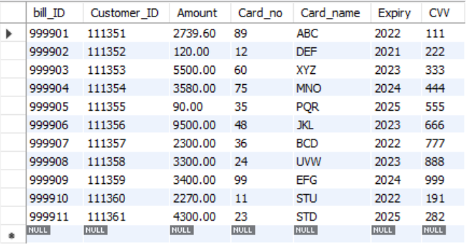

**3.Complex queries based on the concepts of constraints, sets, joins, views, Triggers and Cursors**

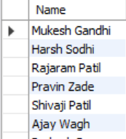

**UNION**

SELECT Farmer_name AS Name FROM Farmer

UNION

SELECT Customer_name FROM Customer;

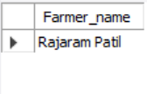**INTERSECT**

SELECT Farmer_name FROM Farmer

INTERSECT

SELECT Customer_name FROM Customer;

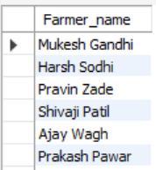**EXCEPT**

SELECT Farmer_name FROM Farmer

EXCEPT

SELECT Customer_name FROM Customer;

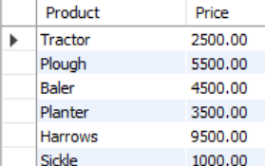**UNION**

SELECT Machine_name AS Product, Price FROM Machinery

UNION

SELECT Fertilizer_name AS Product, Price FROM Fertilizer;

**INTERSECT**

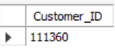SELECT Customer_ID FROM machinery_transaction

WHERE Customer_ID IN (SELECT Customer_ID FROM fertilizer_transaction);

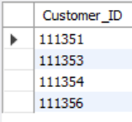**EXCEPT**

SELECT Customer_ID FROM machinery_transaction

WHERE Customer_ID NOT IN (SELECT Customer_ID FROM fertilizer_transaction);

**JOINS**

**Farmer & Crop sold (INNER JOIN)**

SELECT Farmer.Farmer_name, Crop.Crop_name, sell_crop.Price

FROM sell_crop

JOIN Farmer ON sell_crop.Farmer_ID = Farmer.Farmer_ID

JOIN Crop ON sell_crop.Crop_ID = Crop.Crop_ID;

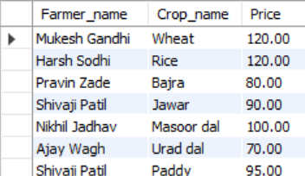

**Crop transactions with Customer & Farmer names**

SELECT Customer.Customer_name, Farmer.Farmer_name, Crop.Crop_name

FROM crop_transaction

JOIN Customer ON crop_transaction.Customer_ID = Customer.Customer_ID

JOIN Farmer ON crop_transaction.Farmer_ID = Farmer.Farmer_ID

JOIN Crop ON crop_transaction.Crop_ID = Crop.Crop_ID;

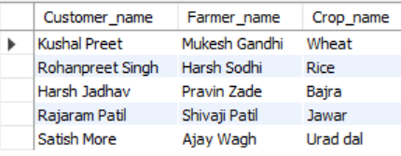

**VIEWS**

**View of Crop Marketplace**

CREATE VIEW Crop_Marketplace AS

SELECT Crop.Crop_name, Farmer.Farmer_name, sell_crop.Price

FROM sell_crop

JOIN Crop ON sell_crop.Crop_ID = Crop.Crop_ID

JOIN Farmer ON sell_crop.Farmer_ID = Farmer.Farmer_ID;

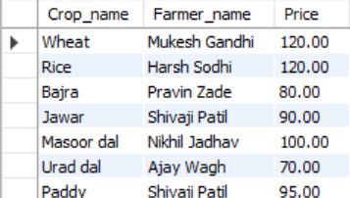

**View of Crop Transactions**

CREATE VIEW Crop_Transactions AS

SELECT Customer.Customer_name, Crop.Crop_name, Farmer.Farmer_name

FROM crop_transaction

JOIN Customer ON crop_transaction.Customer_ID = Customer.Customer_ID

JOIN Farmer ON crop_transaction.Farmer_ID = Farmer.Farmer_ID

JOIN Crop ON crop_transaction.Crop_ID = Crop.Crop_ID;

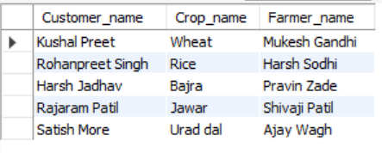

**View of Farmer Details in Crop Sales**

CREATE VIEW Farmer_Sales AS

SELECT Farmer.Farmer_name, Crop.Crop_name, sell_crop.Price

FROM sell_crop

JOIN Farmer ON sell_crop.Farmer_ID = Farmer.Farmer_ID

JOIN Crop ON sell_crop.Crop_ID = Crop.Crop_ID;

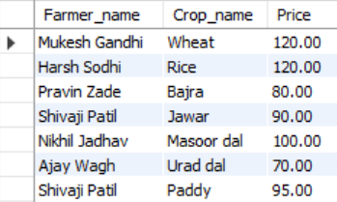

**View of machinery transactions**

CREATE VIEW Machinery_Purchases AS

SELECT Customer.Customer_name, Machinery.Machine_name, Machinery.Price

FROM machinery_transaction

JOIN Customer ON machinery_transaction.Customer_ID = Customer.Customer_ID

JOIN Machinery ON machinery_transaction.Machine_ID = Machinery.Machine_ID;

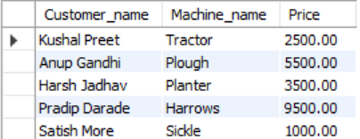

**View of fertilizer transactions**

CREATE VIEW Fertilizer_Purchases AS

SELECT Customer.Customer_name, Fertilizer.Fertilizer_name, Fertilizer.Price

FROM fertilizer_transaction

JOIN Customer ON fertilizer_transaction.Customer_ID = Customer.Customer_ID

JOIN Fertilizer ON fertilizer_transaction.Fertilizer_ID = Fertilizer.Fertilizer_ID;

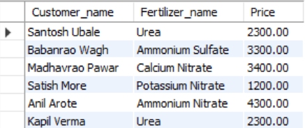

**View of billing**

CREATE VIEW Customer_Billing AS

SELECT Customer.Customer_name, billing.Amount

FROM billing

JOIN Customer ON billing.Customer_ID = Customer.Customer_ID;

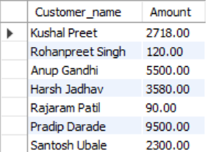

**TRIGGERS**

**Prevent selling a crop below ₹50**

DELIMITER //

CREATE TRIGGER Prevent_Low_Crop_Price

BEFORE INSERT ON sell_crop

FOR EACH ROW

BEGIN

IF NEW.Price < 50 THEN

SIGNAL SQLSTATE '45000' SET MESSAGE_TEXT = 'Crop price too low!';

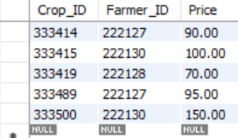 END IF;

END;

//

DELIMITER ;

**Testing the Trigger**

Try inserting a record into sell crop with a price less than ₹50:

INSERT INTO sell crop (Crop ID, Price) VALUES ('333411', 30);

**You should get an error:**



**Trigger to auto-delete crop if quantity drops to zero**

DELIMITER //

CREATE TRIGGER Delete_Empty_Crop

AFTER UPDATE ON Crop

FOR EACH ROW

BEGIN

IF NEW.Quantity_in_kgs = 0 THEN

DELETE FROM Crop WHERE Crop_ID = NEW.Crop_ID;

END IF;

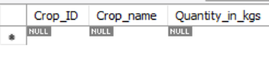END;

//

DELIMITER ;

UPDATE Crop SET Quantity_in_kgs = 0 WHERE Crop_ID = '123456';

**Check if Farmer is registered before selling crop**

DELIMITER //

CREATE TRIGGER Check_Farmer_Exists

BEFORE INSERT ON sell_crop

FOR EACH ROW

BEGIN

IF NOT EXISTS (SELECT 1 FROM Farmer WHERE Farmer_ID = NEW.Farmer_ID) THEN

 SIGNAL SQLSTATE '45000' SET MESSAGE_TEXT = 'Farmer not registered!';

END IF;

END;

//

DELIMITER ;

INSERT INTO sell_crop VALUES ('333509', '999999', 120);



**Ensure Machinery price is not under ₹1000**

DELIMITER //

CREATE TRIGGER Check_Machine_Price

BEFORE INSERT ON Machinery

FOR EACH ROW

BEGIN

IF NEW.Price < 1000 THEN

SIGNAL SQLSTATE '45000' SET MESSAGE_TEXT = 'Machine price too low!';

END IF;

END;

//

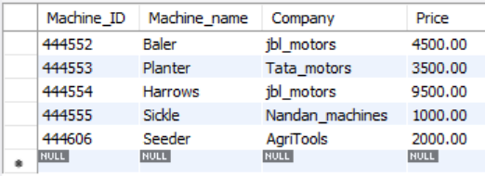DELIMITER ;

INSERT INTO Machinery VALUES ('444606', 'Seeder', 'AgriTools', 2000);

**Prevent duplicate fertilizer names**

DELIMITER //

CREATE TRIGGER Unique_Fertilizer

BEFORE INSERT ON Fertilizer

FOR EACH ROW

BEGIN

IF EXISTS (SELECT 1 FROM Fertilizer WHERE Fertilizer_name = NEW.Fertilizer_name) THEN

SIGNAL SQLSTATE '45000' SET MESSAGE_TEXT = 'Fertilizer name must be unique';

END IF;

END;

//

DELIMITER ;

INSERT INTO Farmer VALUES

('222209', 'Raj', 9998887770, 'raj@gmail.com', 'Chennai', 'pass6');

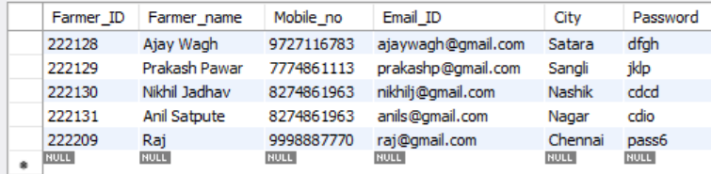

**CURSORS**

**Cursor to display all crops**

DELIMITER //

CREATE PROCEDURE Show_Crops()

BEGIN

DECLARE c_name VARCHAR(20);

DECLARE done INT DEFAULT FALSE;

DECLARE cur CURSOR FOR SELECT Crop_name FROM Crop;

DECLARE CONTINUE HANDLER FOR NOT FOUND SET done = TRUE;

OPEN cur;

read_loop: LOOP

FETCH cur INTO c_name;

IF done THEN LEAVE read_loop; END IF;

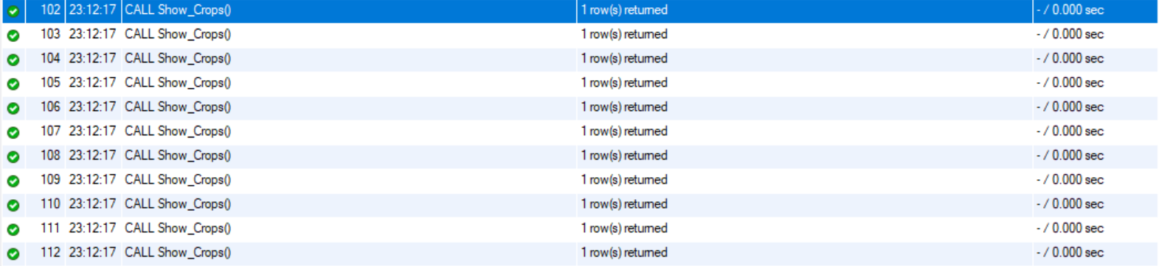 SELECT c_name;

END LOOP;

CLOSE cur;

END;

//

DELIMITER ;

CALL Show_Crops();

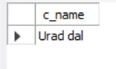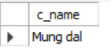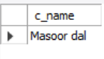

**Cursor to show Farmers selling crops**

DELIMITER //

CREATE PROCEDURE Show_Farmer_Sales()

BEGIN

DECLARE fname VARCHAR(20);

DECLARE done INT DEFAULT FALSE;

DECLARE cur CURSOR FOR

SELECT Farmer.Farmer_name FROM sell_crop

JOIN Farmer ON sell_crop.Farmer_ID = Farmer.Farmer_ID;

DECLARE CONTINUE HANDLER FOR NOT FOUND SET done = TRUE;

OPEN cur;

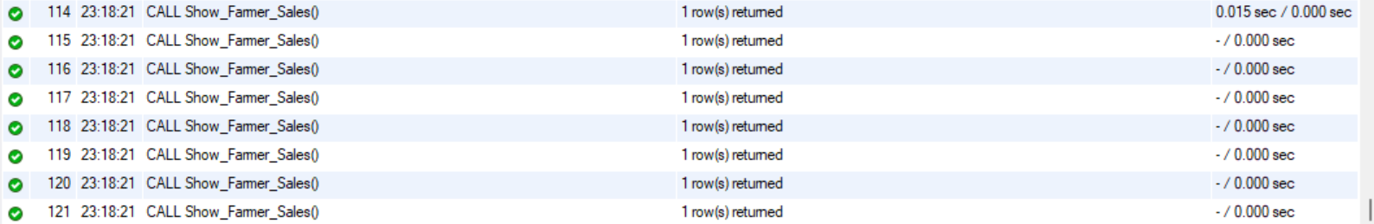 read_loop: LOOP

FETCH cur INTO fname;

IF done THEN LEAVE read_loop; END IF;

SELECT fname;

END LOOP;

CLOSE cur;

END;

//

DELIMITER ;

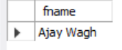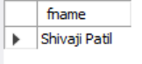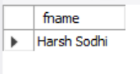CALL Show_Farmer_Sales();

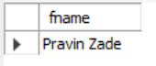

**Cursor to show Customers in crop transactions**

DELIMITER //

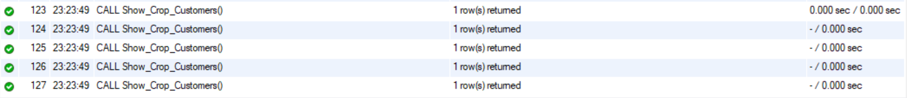CREATE PROCEDURE Show_Crop_Customers()

BEGIN

DECLARE cname VARCHAR(20);

DECLARE done INT DEFAULT FALSE;

DECLARE cur CURSOR FOR

SELECT Customer.Customer_name FROM crop_transaction

JOIN Customer ON crop_transaction.Customer_ID = Customer.Customer_ID;

DECLARE CONTINUE HANDLER FOR NOT FOUND SET done = TRUE;

OPEN cur;

read_loop: LOOP

FETCH cur INTO cname;

IF done THEN LEAVE read_loop; END IF;

SELECT cname;

END LOOP;

CLOSE cur;

END;

//

DELIMITER ;

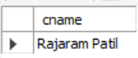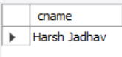CALL Show_Crop_Customers();

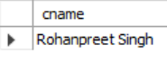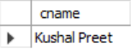

**Cursor to display all machines**

DELIMITER //

CREATE PROCEDURE Show_Machines()

BEGIN

DECLARE m_name VARCHAR(20);

DECLARE done INT DEFAULT FALSE;

DECLARE cur CURSOR FOR SELECT Machine_name FROM Machinery;

DECLARE CONTINUE HANDLER FOR NOT FOUND SET done = TRUE;

OPEN cur;

read_loop: LOOP

FETCH cur INTO m_name;

IF done THEN LEAVE read_loop; END IF;

SELECT m_name;

END LOOP;

CLOSE cur;

END;

//

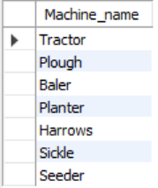DELIMITER ;

SELECT Machine_name FROM Machinery;

**Cursor to show all fertilizers**

DELIMITER //

CREATE PROCEDURE Show_Fertilizers()

BEGIN

DECLARE f_name VARCHAR(20);

DECLARE done INT DEFAULT FALSE;

DECLARE cur CURSOR FOR SELECT Fertilizer_name FROM Fertilizer;

DECLARE CONTINUE HANDLER FOR NOT FOUND SET done = TRUE;

OPEN cur;

read_loop: LOOP

FETCH cur INTO f_name;

IF done THEN LEAVE read_loop; END IF;

SELECT f_name;

END LOOP;

CLOSE cur;

END;

//

DELIMITER ;

SELECT Fertilizer_name FROM Fertilizer;

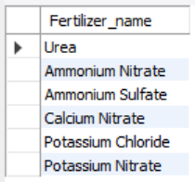

**Cursor to show customers with billing**

DELIMITER //

CREATE PROCEDURE Show_Billing_Customers()

BEGIN

DECLARE c_name VARCHAR(20);

DECLARE done INT DEFAULT FALSE;

DECLARE cur CURSOR FOR

SELECT Customer.Customer_name FROM billing

JOIN Customer ON billing.Customer_ID = Customer.Customer_ID;

DECLARE CONTINUE HANDLER FOR NOT FOUND SET done = TRUE;

OPEN cur;

read_loop: LOOP

FETCH cur INTO c_name;

IF done THEN LEAVE read_loop; END IF;

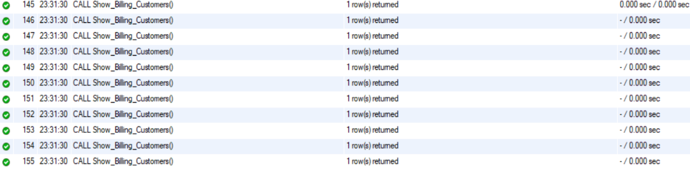 SELECT c_name;

END LOOP;

CLOSE cur;

END;

//

DELIMITER ;

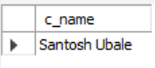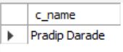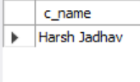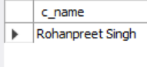CALL Show_Billing_Customers();

**4.Analyzing the pitfalls, identifying the dependencies, and applying normalizations**

* Normal Tables Output:

**Table 1 (farmer) Table 2 (Farmer Crop)**

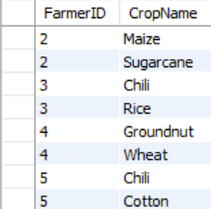 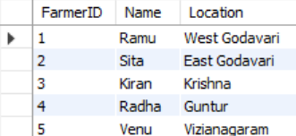

**Table 3 (Farmer Tool)**

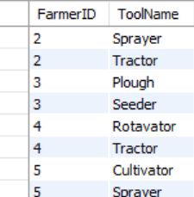

**First Normal Form (1NF) :** **Show All Farmers**

It is a basic requirement in database normalization, ensuring that a relational database table's structure is free of repeating groups and each column contains atomic values. In short, 1NF requires.

**1. Atomic Values**: Each cell in a table should contain a single, indivisible value. Columns should not contain multiple values or groups of values.

**2. No Repeating** **Groups:** Each column should hold values of the same type, and each row should represent a unique combination of values. There should be no repeating groups of columns or multiple values within a single column.

By adhering to 1NF, data redundancy and inconsistencies are reduced, making it easier to store, retrieve, and manipulate data in a relational database system.



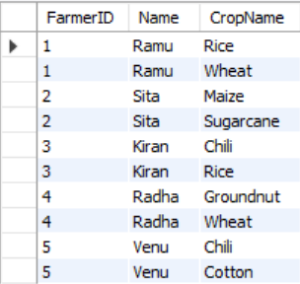**Second Normal Form (2NF) :** **Show All Crops Grown by Each Farmer**

2NF eliminates partial dependencies by ensuring every non-prime attribute is fully functionally dependent on the primary key.

It requires that every non-prime attribute is dependent on the entire primary key, not just a part of it.

SELECT * FROM Farmer;

SELECT f.FarmerID, f.Name, fc.CropName

FROM Farmer f

JOIN Farmer_Crop fc ON f.FarmerID = fc.FarmerID

ORDER BY f.FarmerID;

**Third Normal Form (3NF):** **Show All Tools Used by Each Farmer**

**No Transitive Dependencies**: 3NF deals with eliminating transitive dependencies within a table. A transitive dependency occurs when a non-prime attribute depends on another non-prime attribute which is not its candidate key.

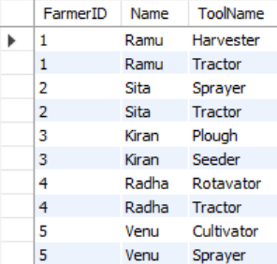

**Attributes Independent of Each Other:** Every non-prime attribute must be functionally dependent on the primary key, and only the primary key.

**Elimination of Redundancy**: By eliminating transitive dependencies, 3NF helps reduce redundancy in data storage, making updates and modifications more efficient and less error-prone.

Table no. 4f

SELECT f.FarmerID, f.Name, ft.ToolName

FROM Farmer f

JOIN Farmer_Tool ft ON f.FarmerID = ft.FarmerID

ORDER BY f.FarmerID;

**Boycee Codd Normal Form (BCNF) :**

Sure, here's a brief explanation of the BCNF conditions in two lines each:

1. No redundancy: BCNF eliminates redundant data by ensuring that each non-trivial functional dependency is based on a candidate key, preventing unnecessary repetition.

2. Focused tables:BCNF requires each table to be focused on a single topic, ensuring that there are no overlapping or mixed concerns within the same table, which promotes data clarity and integrity.

Why This Satisfies BCNF

In all tables, every non-trivial functional dependency has a superkey on the left side.

There are no partial or transitive dependencies.

No anomalies (insertion, update, or deletion) are present.

**Fourth Normal Form (4NF):**

**Multivalued Dependency Elimination**: 4NF goes a step further than 3NF by addressing multivalued dependencies. A multivalued dependency exists when two or more independent multi-valued attributes are present in a table.

**Separation of Independent Multivalued Facts**: 4NF ensures that each multi-valued fact is stored in a separate table, thereby preventing duplication of information and reducing anomalies.

**Higher Level of Normalization**: Compared to 3NF, 4NF provides a higher level of normalization, resulting in more organized and efficient database structures.

SELECT f.FarmerID, f.Name, GROUP_CONCAT(fc.CropName) AS Crops

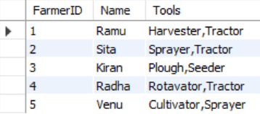FROM Farmer f

JOIN Farmer_Crop fc ON f.FarmerID = fc.FarmerID

GROUP BY f.FarmerID;

-- All tools per farmer (aggregated)

SELECT f.FarmerID, f.Name, GROUP_CONCAT(ft.ToolName) AS Tools

FROM Farmer f

JOIN Farmer_Tool ft ON f.FarmerID = ft.FarmerID

GROUP BY f.FarmerID;

**5.Implementation of Concurrency Control and Recovery Mechanism**

In a multi-user environment like the Agri-Market system, multiple farmers and customers can access and interact with the database simultaneously. This can lead to conflicts, such as two users trying to modify the same data at the same time (e.g., updating crop quantity, placing an order, or processing a payment). To handle this, we implement concurrency control and recovery mechanisms to ensure data consistency, integrity, and reliability.

**1. Concurrency Control**

Concurrency control ensures that database transactions are executed in a safe, consistent way when multiple users perform operations at the same time.

**Methods used:**

**Locking Mechanisms:**

Read Locks (Shared Locks): Multiple users can read data, but not modify it until the lock is released.

Write Locks (Exclusive Locks): Only one user can write or update data at a time.

For example, when a customer places an order, a write lock is used on crop quantity to prevent others from modifying it until the current transaction completes.

**Transaction Isolation Levels (as in SQL):**

The database uses isolation levels like READ COMMITTED or SERIALIZABLE to avoid issues like dirty reads, non-repeatable reads, and phantom reads.

In Agri-Market, REPEATABLE READ or SERIALIZABLE levels can be applied to sensitive operations like billing or inventory updates.

**Timestamp Ordering (if needed):**

Assigning a timestamp to each transaction and executing them based on their order, ensuring consistency without manual locks.

Recovery Mechanism

Recovery mechanisms help the system recover to a stable state in case of failure (like power loss, software crash, or improper shutdown).

**Key strategies:**

**Transaction Logging:**

Every transaction is logged with details like operation type, data affected, and before/after values.

Logs are used to roll back (undo) incomplete transactions or roll forward (redo) committed ones after a crash.

**ACID Properties Enforcement:**

1. Atomicity: Every transaction is all-or-nothing. If any part fails, the whole transaction is rolled back.
2. Consistency: The database moves from one consistent state to another.
3. Isolation: No transaction interferes with another.
4. Durability: Once committed, data is permanently saved, even after a failure.

**Checkpointing:**

Periodic snapshots of the database are taken. In the event of failure, the system can recover quickly by starting from the last checkpoint instead of scanning the entire log.

**Transactions**

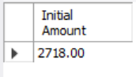**Transaction 1: Add GST (18%) to a crop price and update billing**

**-**- Show initial billing amount

SELECT Amount AS 'Initial Amount'

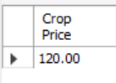FROM billing

WHERE Customer_ID = '111351';

-- Show crop price before transaction

SELECT Price AS 'Crop Price'

FROM sell_crop

WHERE Crop_ID = '333411' AND Farmer_ID = '222123';

START TRANSACTION;

-- Fetch the original price

SET @crop_price = (SELECT Price FROM sell_crop WHERE Crop_ID = '333411' AND Farmer_ID = '222123');

-- Calculate GST (18%)

SET @gst = ROUND(@crop_price * 0.18, 2);

-- Update billing amount for the respective customer

UPDATE billing

SET Amount = Amount + @gst

WHERE Customer_ID = '111351';

IF ROW_COUNT() = 0 THEN

ROLLBACK;

ELSE

COMMIT;

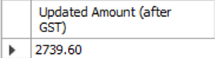END IF;

**AFTER:**

-- Show new billing amount

SELECT Amount AS 'Updated Amount (after GST)'

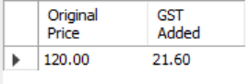FROM billing

WHERE Customer_ID = '111351';

-- Optional: Show GST value that was applied

SELECT @crop_price AS 'Original Price', @gst AS 'GST Added';

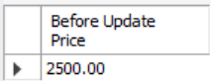**Transaction 2: Update machinery price and reflect in billing (Rollback if price is unusually high)**

-- Step 1: Show the price BEFORE transaction

SELECT Price AS 'Before Update Price'

FROM Machinery

WHERE Machine_ID = '444550';

-- Step 2: Start the transaction

START TRANSACTION;

UPDATE Machinery

SET Price = 12000

WHERE Machine_ID = '444550';

-- Step 3: Get the new price

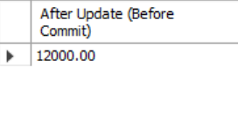SELECT Price AS 'After Update (Before Commit)'

FROM Machinery

WHERE Machine_ID = '444550';

-- Now, check the price manually and commit or rollback accordingly:

-- If the price is more than 10000, rollback:

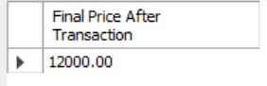**ROLLBACK;**

-- Or, if the price is okay (<= 10000), commit:

-- COMMIT;

--: Final price after transaction ends

SELECT Price AS 'Final Price After Transaction'

FROM Machinery

WHERE Machine_ID = '444550';

**Transaction 3: Add a new crop sale – rollback if crop ID doesn't exist**

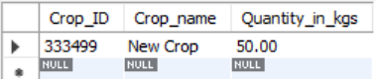-- Step 1: Show crop details BEFORE transaction

SELECT * FROM Crop WHERE Crop_ID = '333499';

-- Step 2: Check if the crop exists

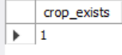SELECT COUNT(*) AS crop_exists FROM Crop WHERE Crop_ID = '333499';

--If crop_exists = 1, proceed to the transaction below.

-- Step 3: Start transaction

START TRANSACTION;

-- Step 4: Insert into sell_crop if crop exists

INSERT INTO sell_crop (Crop_ID, Farmer_ID, Price)

VALUES ('333499', '222127', 95);

-- Step 5: Commit the transaction

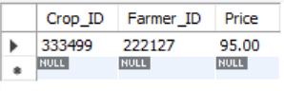COMMIT;

-- If the crop didn't exist, you would SKIP steps 3–5.

SELECT * FROM sell_crop

WHERE Crop_ID = '333499' AND Farmer_ID = '222127';

**Transaction 4: Customer buys a fertilizer and pays**

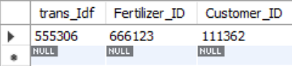-- Show fertilizer transaction before transaction

SELECT * FROM fertilizer_transaction WHERE Customer_ID = '111362';

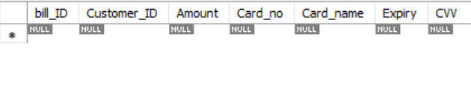-- Show billing data before transaction

SELECT * FROM billing WHERE Customer_ID = '111362';

START TRANSACTION;

-- Add new fertilizer transaction

INSERT INTO fertilizer_transaction(trans_IDf, Fertilizer_ID, Customer_ID)

VALUES ('555306', '666123', '111362');

-- Add to billing

UPDATE billing

SET Amount = Amount + 2300

WHERE Customer_ID = '111362';

-- Check card number validity (simple check)

SET @card = (SELECT Card_no FROM billing WHERE Customer_ID = '111362');

IF @card < 10 THEN

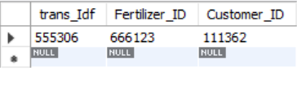 ROLLBACK;

ELSE

COMMIT;

END IF;

-- Show fertilizer transaction after transaction

SELECT * FROM fertilizer_transaction WHERE Customer_ID = '111362';

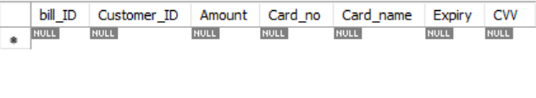-- Show billing data after transaction

SELECT * FROM billing WHERE Customer_ID = '111362';

**Transaction 5: Delete a farmer and rollback if crops are still assigned to them**

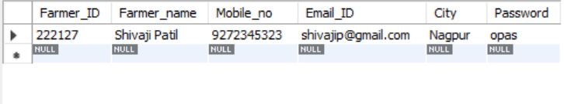-- Show the farmer details before transaction

SELECT * FROM Farmer WHERE Farmer_ID = '222127';

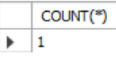-- Show the number of crops the farmer has before the transaction

SELECT COUNT(*) FROM sell_crop WHERE Farmer_ID = '222127';

START TRANSACTION;

-- Check if farmer has crops

SET @crop_count = (SELECT COUNT(*) FROM sell_crop WHERE Farmer_ID = '222127');

-- If no crops, delete farmer

IF @crop_count = 0 THEN

DELETE FROM Farmer WHERE Farmer_ID = '222127';

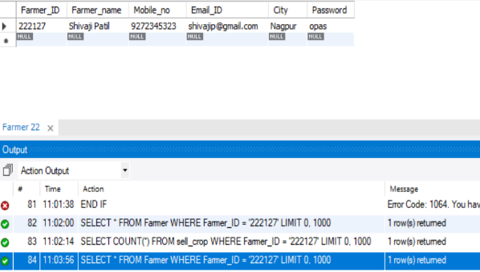 COMMIT;

ELSE

ROLLBACK;

END IF;

-- Show farmer details after transaction

SELECT * FROM Farmer WHERE Farmer_ID = '222127';

-- Show the number of crops the farmer has after the transaction

SELECT COUNT(*) FROM sell_crop WHERE Farmer_ID = '222127';

**Transaction 6: Customer Billing Update After Purchase**

START TRANSACTION;

-- Step 1: Show initial billing amount for the customer

SELECT Amount AS 'Initial Amount' FROM billing WHERE Customer_ID = '111351';

-- Step 2: Fetch crop price for purchase

SET @crop_price = (SELECT Price FROM sell_crop WHERE Crop_ID = '333411' AND Farmer_ID = '222123');

-- Step 3: Update the billing amount with the crop price

UPDATE billing

SET Amount = Amount + @crop_price

WHERE Customer_ID = '111351';

-- Step 4: Show updated billing amount after crop purchase

SELECT Amount AS 'Updated Amount' FROM billing WHERE Customer_ID = '111351';

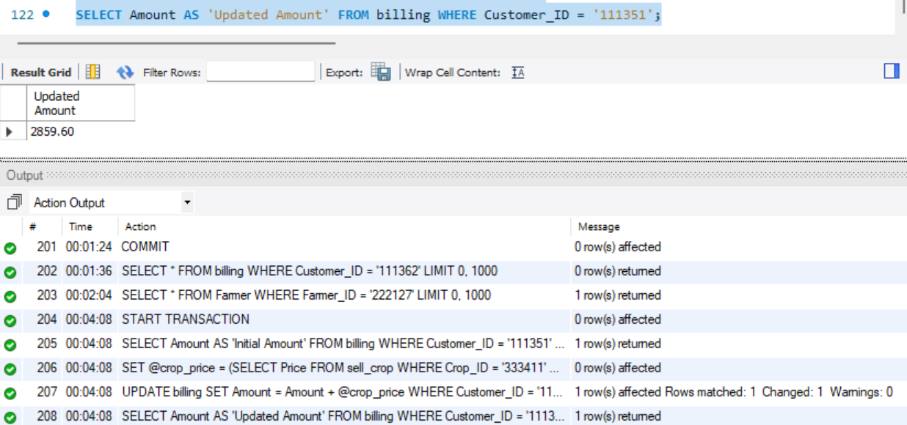

**Transaction 7: Update Farmer's Crop Price After Market Price Change**

START TRANSACTION;

-- Step 1: Show the initial crop price

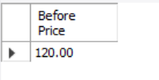SELECT Price AS 'Before Price' FROM sell_crop WHERE Crop_ID = '333411' AND Farmer_ID = '222123';

-- Step 2: Update the price for the crop

UPDATE sell_crop

SET Price = 150

WHERE Crop_ID = '333411' AND Farmer_ID = '222123';

-- Step 3: Check if the price is above the threshold (100)

SET @new_price = (SELECT Price FROM sell_crop WHERE Crop_ID = '333411' AND Farmer_ID = '222123');

IF @new_price > 100 THEN

**COMMIT;**

ELSE

ROLLBACK;

END IF;

-- Step 4: Show the updated crop price

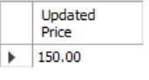SELECT Price AS 'Updated Price' FROM sell_crop WHERE Crop_ID = '333411' AND Farmer_ID = '222123';

COMMIT;

**Transaction : Add New Crop for a Farmer and Update Sell Crop Table**

START TRANSACTION;

-- Step 1: Check if the farmer exists (we'll use '222130' for the farmer)

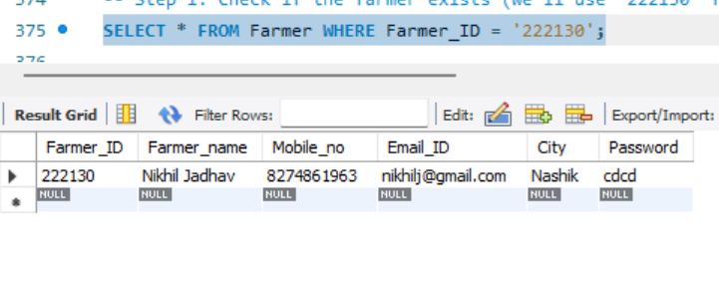SELECT * FROM Farmer WHERE Farmer_ID = '222130';

-- Step 2: Insert a new crop called 'Tomato' into the Crop table (if not already existing)

INSERT INTO Crop (Crop_ID, Crop_name, Quantity_in_kgs)

VALUES ('333500', 'Tomato', 40);

-- Step 3: Insert a new sell crop entry for the farmer

INSERT INTO sell_crop (Crop_ID, Farmer_ID, Price)

VALUES ('333500', '222130', 150);

-- Step 4: Check if the crop was successfully added to the sell_crop table

SELECT * FROM sell_crop WHERE Crop_ID = '333500' AND Farmer_ID = '222130';

COMMIT;

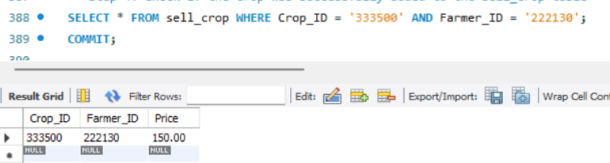

**6.Result and Discussion (Screen shots of the implementation with front end).**

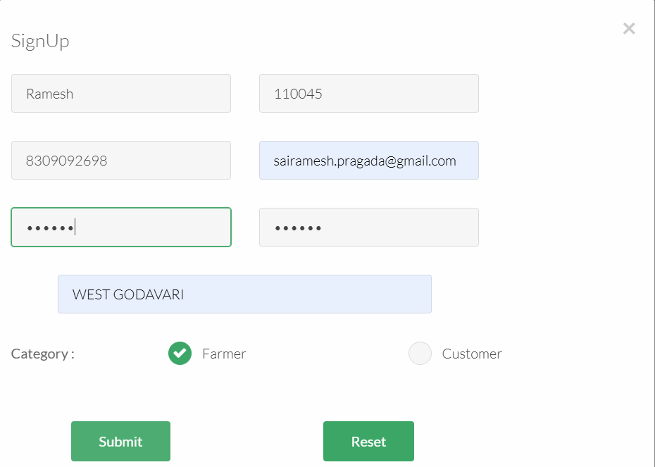**6.1 Main Front**

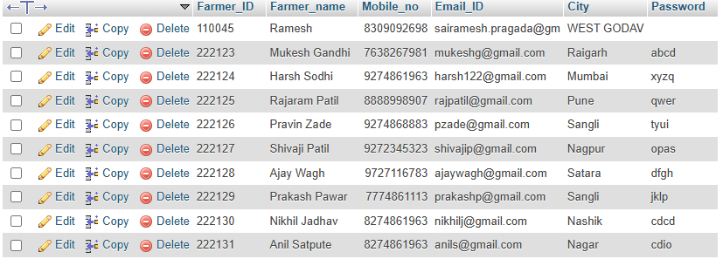

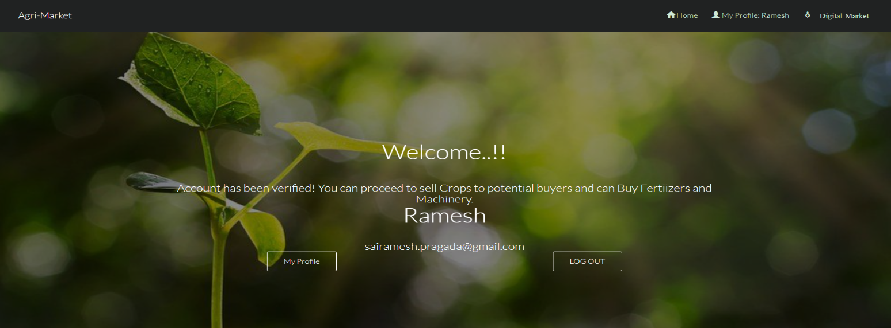 **6.2 Sign Up (Farmer) 6.2 (Database)**

**6.3 (New Account)**

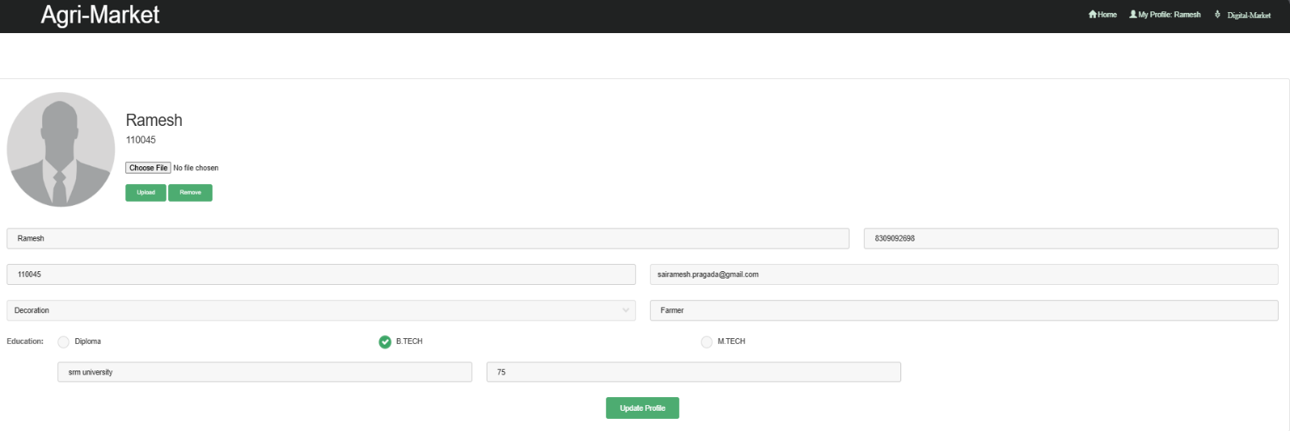**6.4(Farmer Profile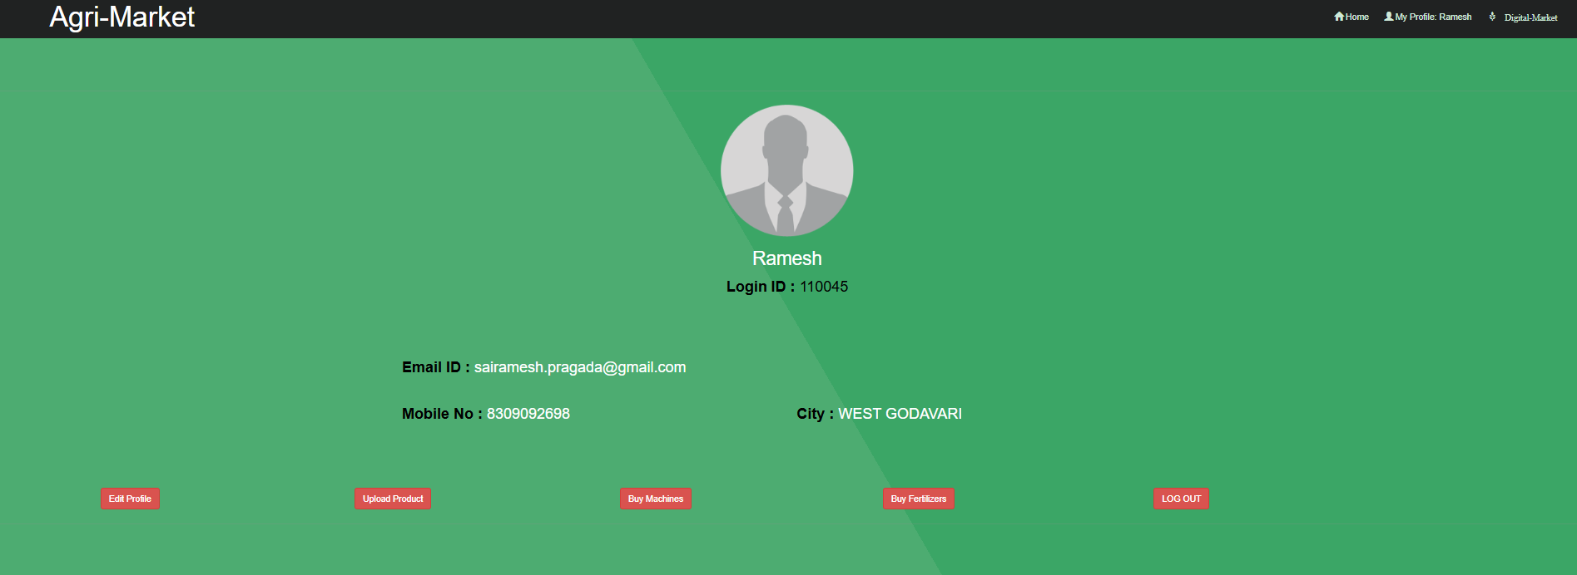)**

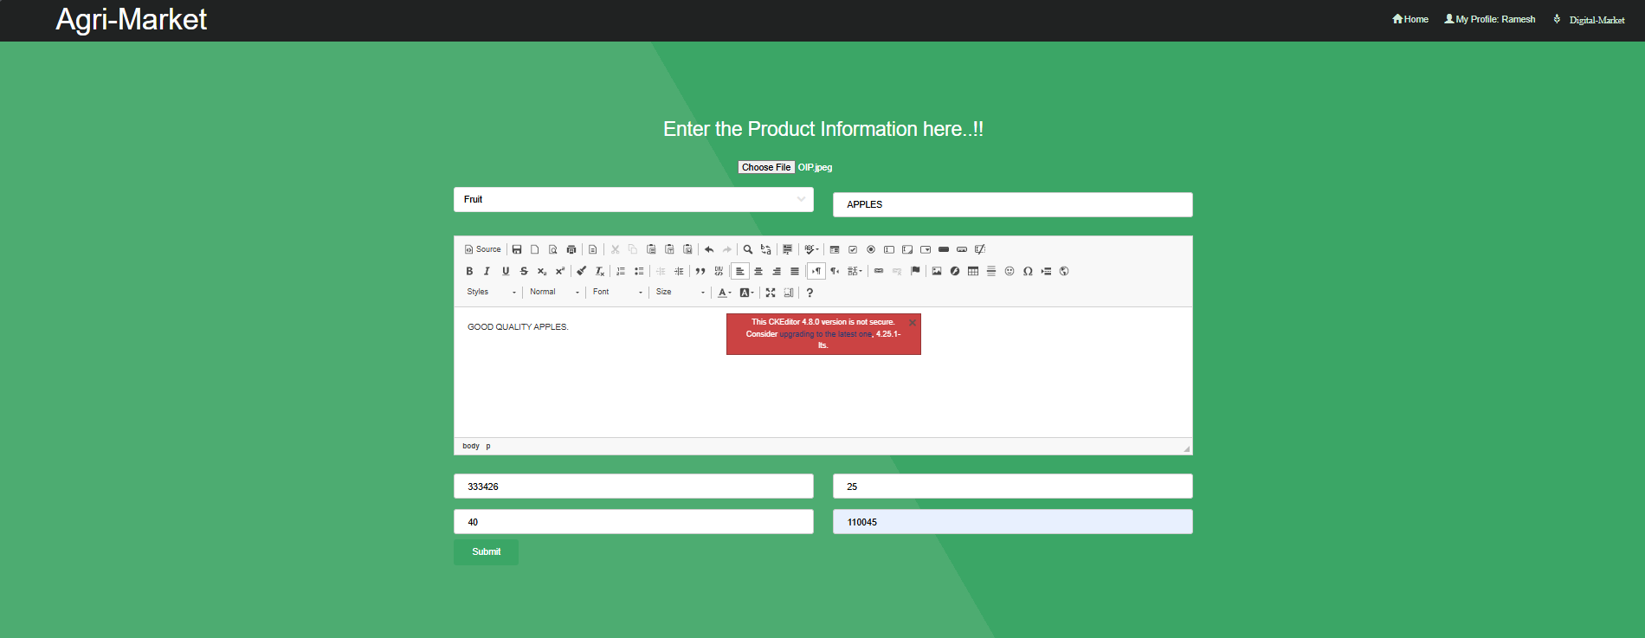**6.5(Edit Profile)**

**6.6(Upload Crop)**

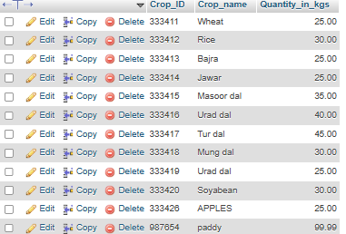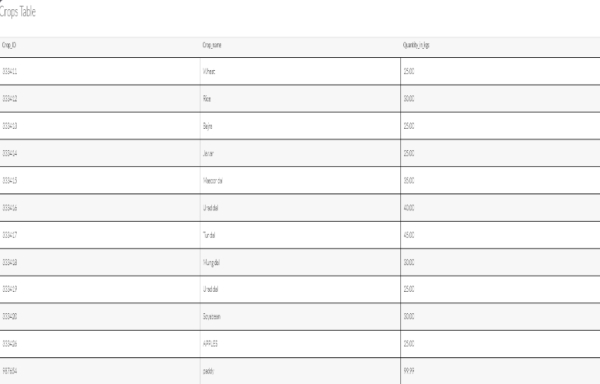

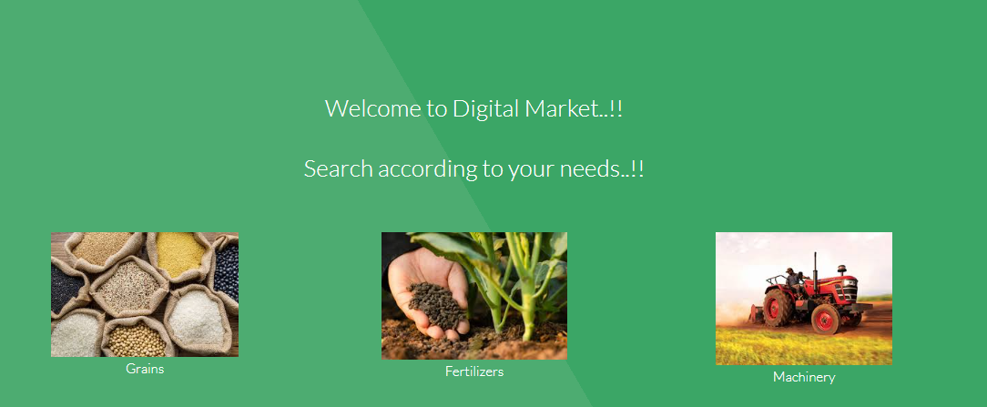 **6.7(Crop Data) 6.7(Crop Added)**

**6.8(Product Search)**

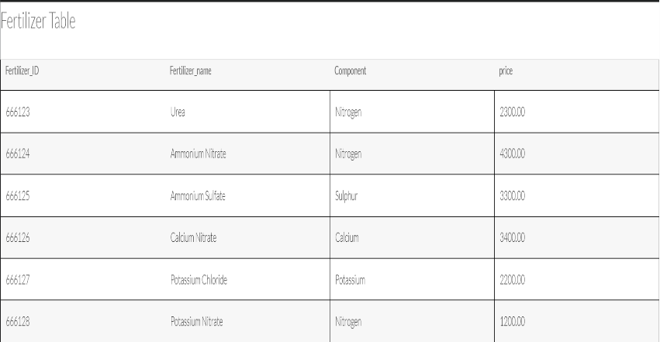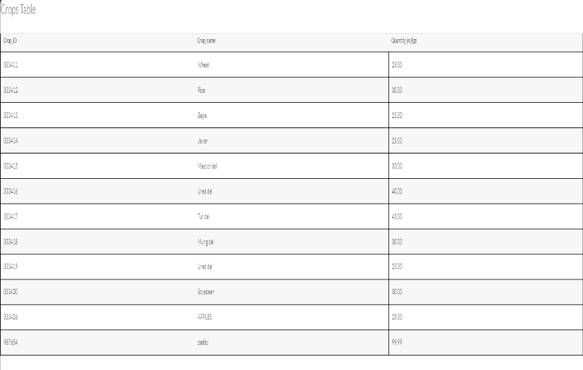

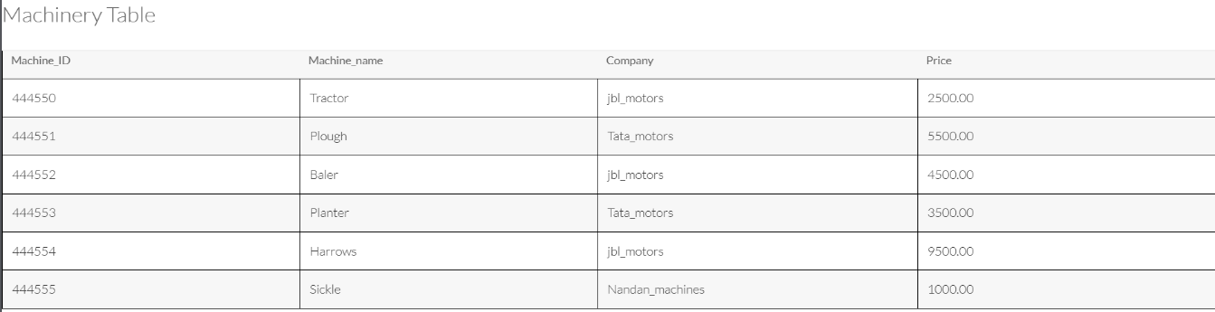

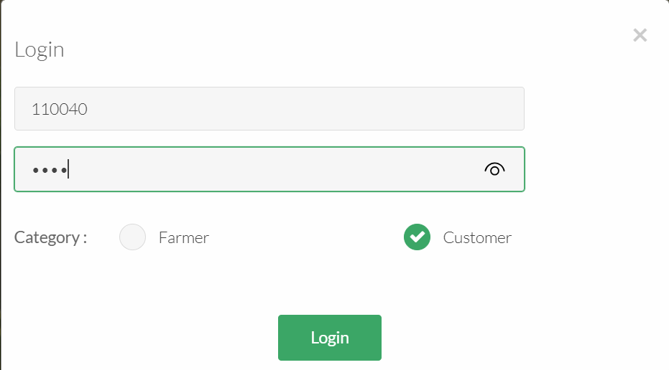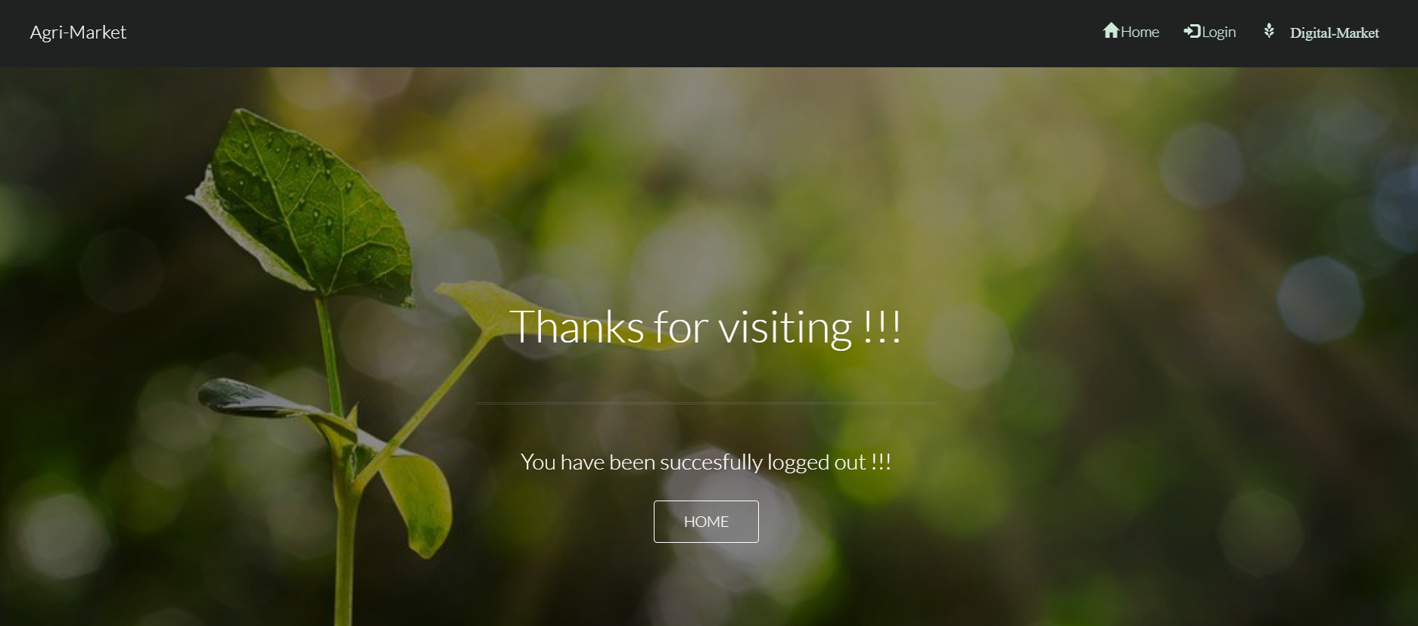**6.9 (Farmer Logout)**

**6.10(Customer Login)**

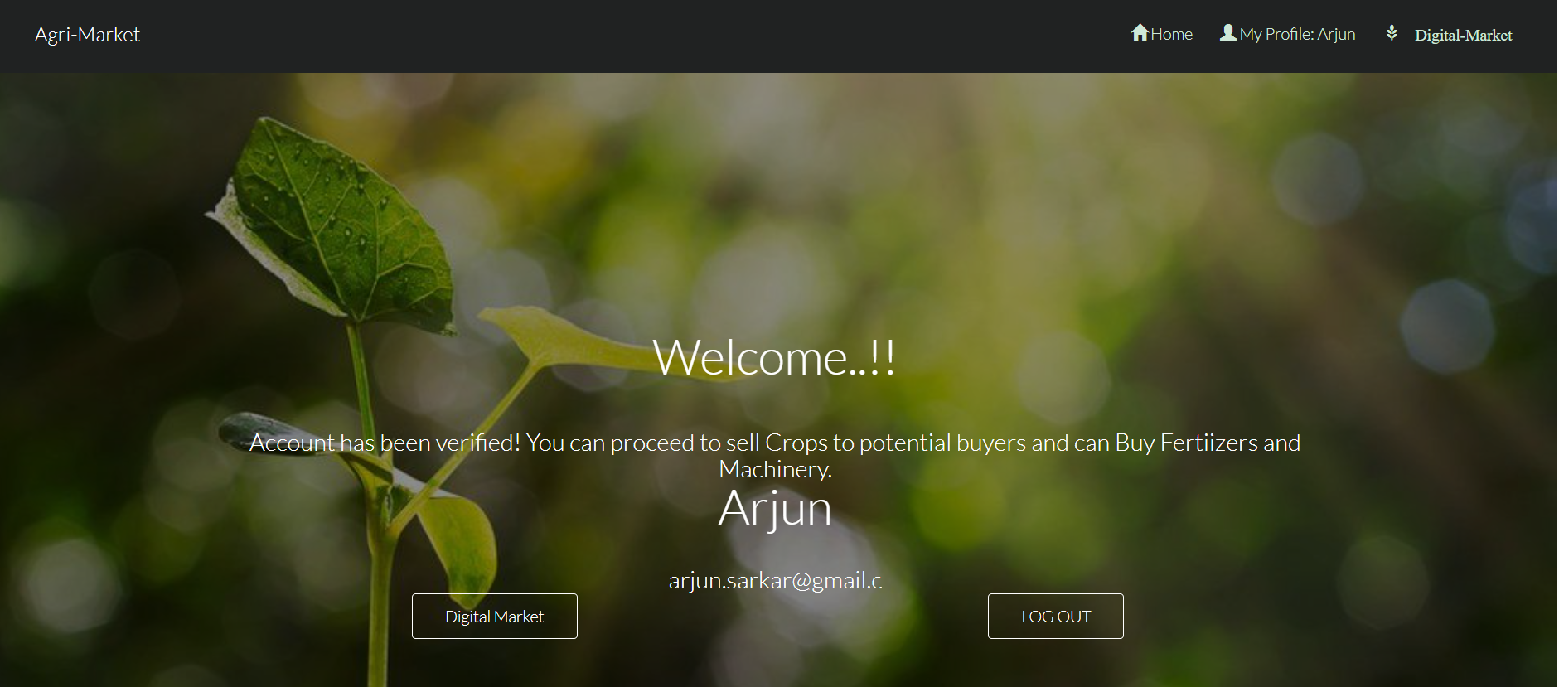

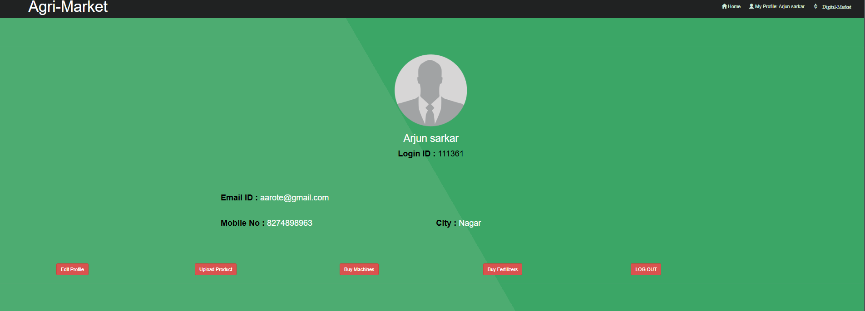**6.10(Customer Profile)**

**6.11(Customer Profile Edit)**

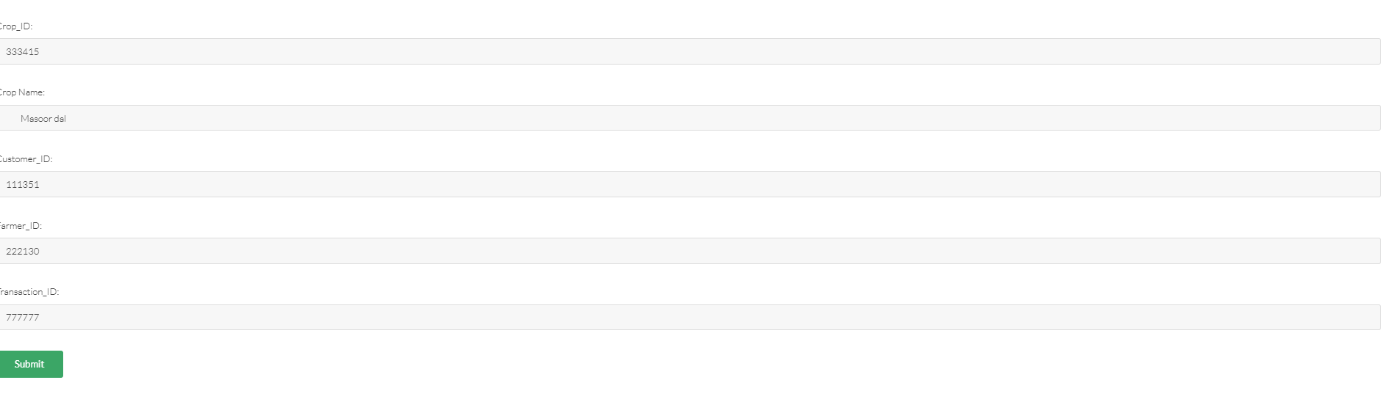**6.12 (Buying Crop from Farmer)**

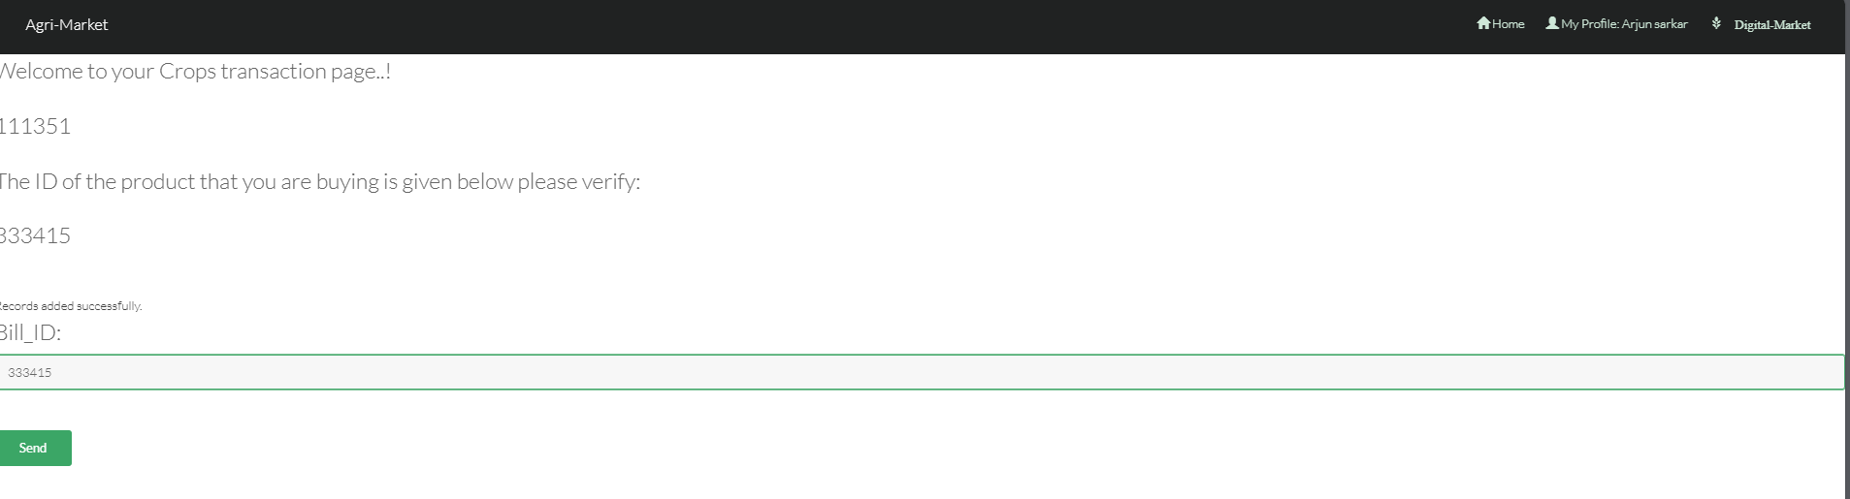

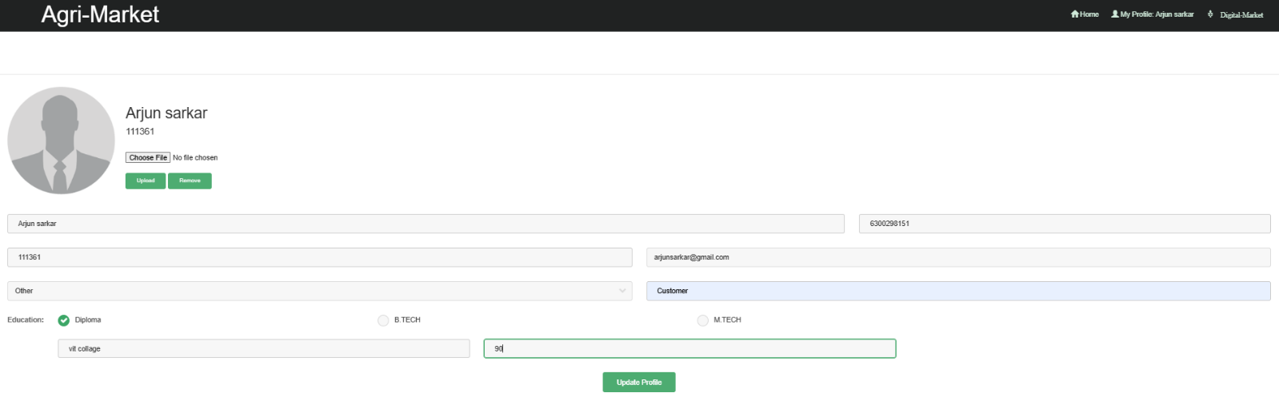**6.13 (Crop Transaction)**

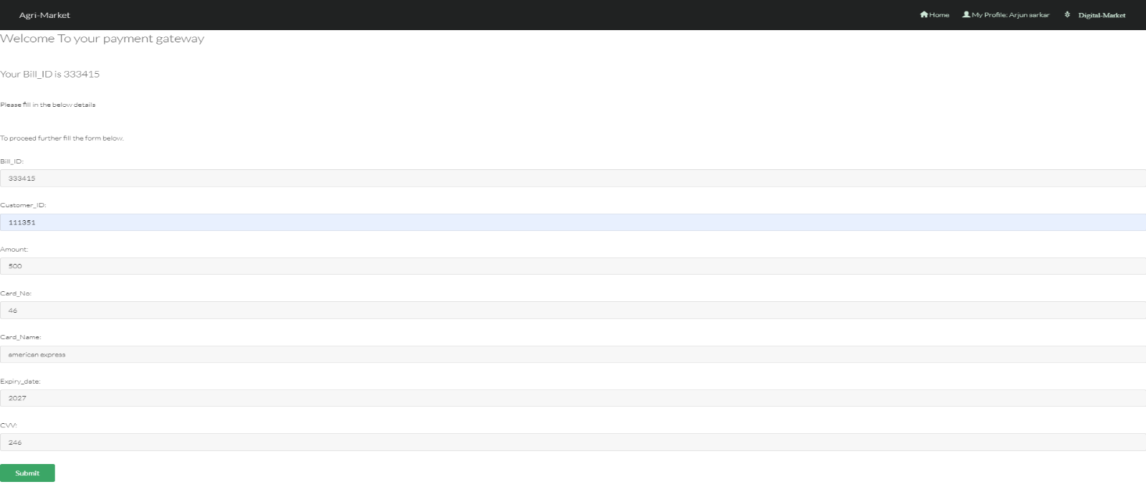**6.14(Crop Billing)**

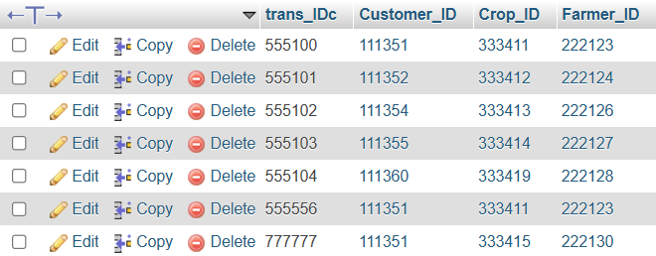

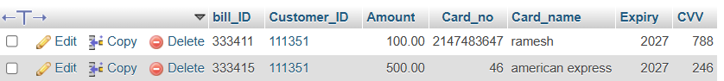**Database (Crop Transaction)**

**Database (Billing)**

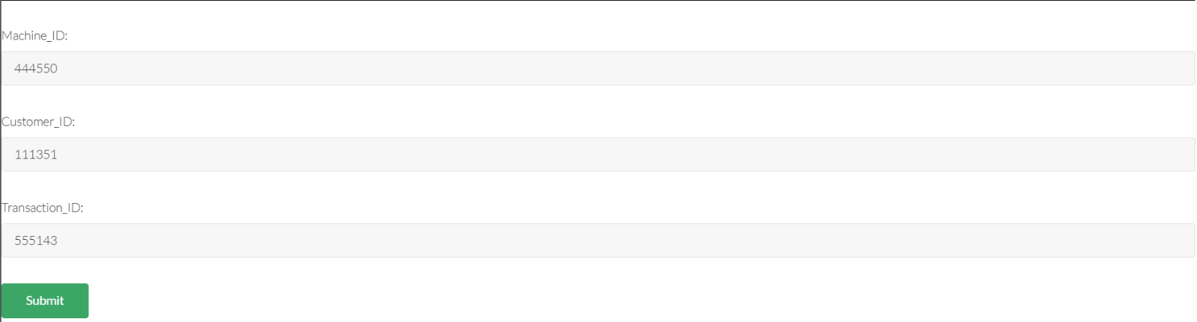**6.15(Buying Machine)**

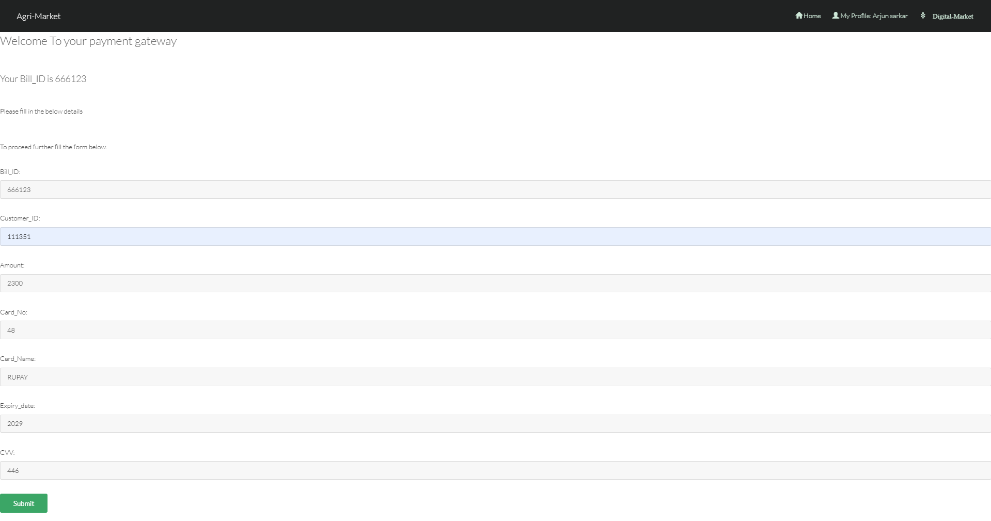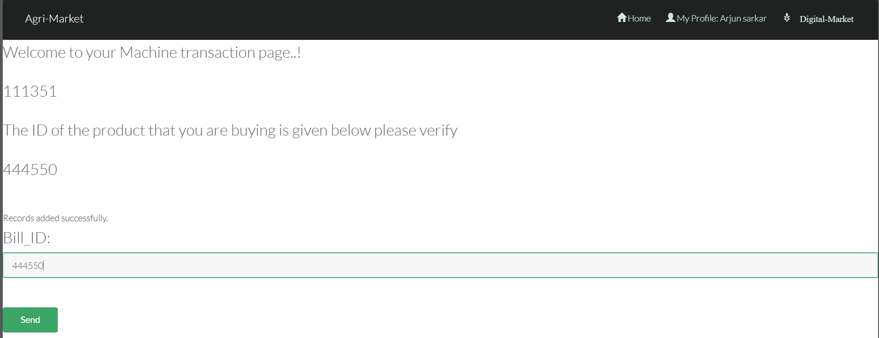**6.16(Machine Transaction)**

**6.17(Crop Billing)**

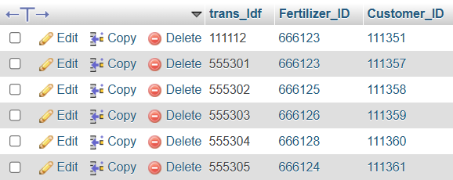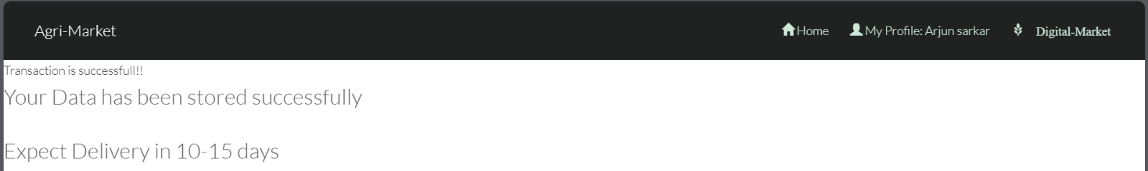**6.18(Transaction Success)**

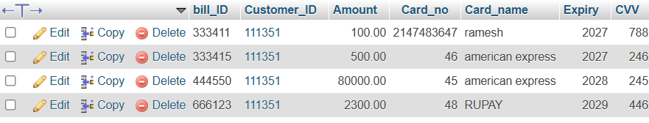**Database (Machine Transaction)**

**Database (Billing)**

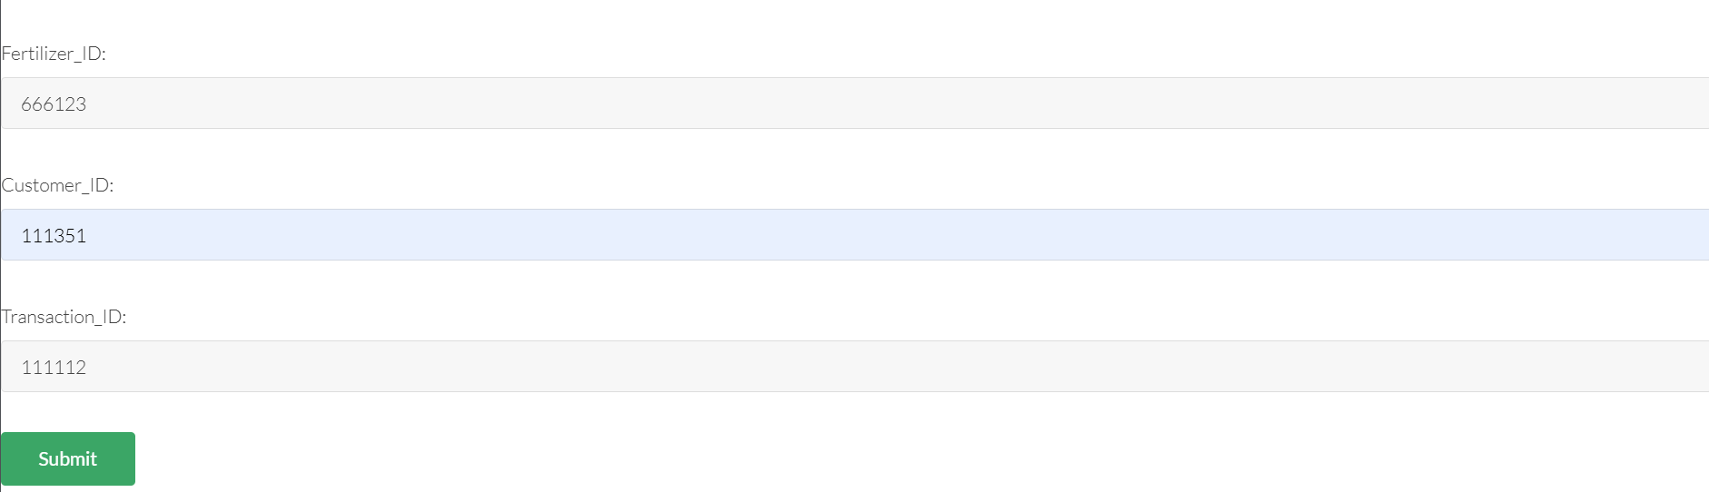

**6.19(Buying Fertilizers)**

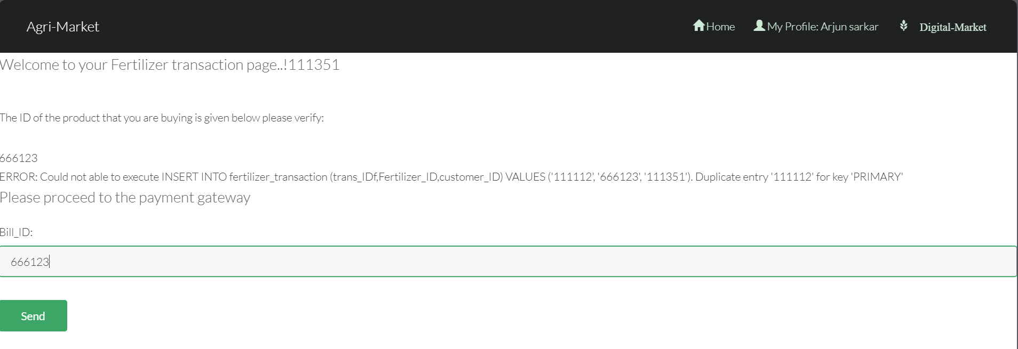

**6.20(Fertilizer Transaction)**

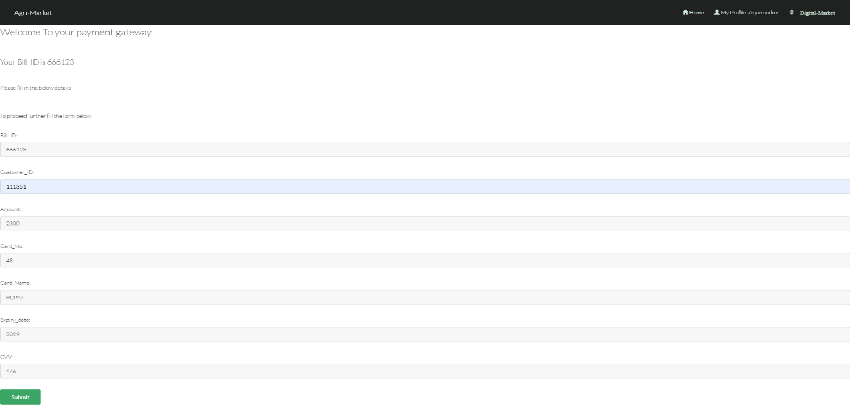

**6.21(Fertilizer Billing)**

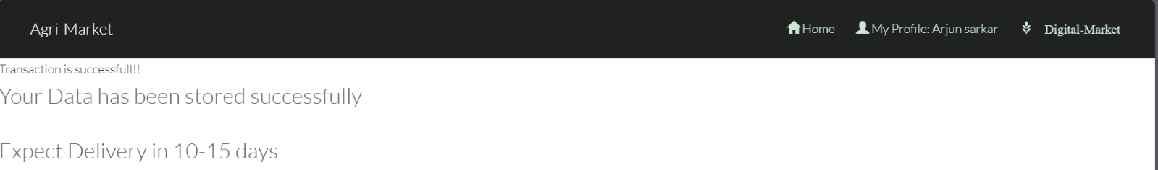

**6.22(Transaction Success)**



**Database (Fertilizer Transaction)**

**Database (Billing)**

**Technology used:**

* HTML/ CSS/ JS for Frontend
* PHP for backend
* MySQL database

**Features:**

* User can register as a Farmer or a Customer.
* If user is Farmer then he will be able to sell his products(grains) to the customers.
* Farmers can also buy fertilizers and machinery from the website.
* If you are logged in as customer you can buy crops and grains from Farmers.
* You can see profiles of farmers and also the prices they are selling their crops with.

**Conclusion**

The Farmer management system project is not just a technical system—it’s a thoughtful response to real challenges faced by the agricultural community. In today’s world, where farmers often struggle with limited market access, middlemen exploitation, and lack of transparency in pricing, this project provides a refreshing, practical, and much-needed solution.

At its core, Agri-Market serves as a digital bridge between farmers and consumers. It empowers farmers by giving them the ability to register themselves on the platform, showcase their products, set their own prices, and sell directly to customers without relying on middlemen. This simple change can have a big impact—it helps farmers earn better profits and gives them a sense of ownership over their produce and pricing.

On the other side, customers also benefit from this transparent system. They can log in, browse the available crops or grains, compare prices from different farmers, and make informed decisions. The ability to view detailed farmer profiles adds a layer of trust, helping customers feel confident about the source and quality of the products they are buying.

The platform also goes a step further by supporting the entire farming ecosystem. Farmers are not just sellers—they’re also buyers of essential items like fertilizers and farming machinery. Agri-Market lets them purchase agricultural inputs directly from the system, helping them reduce the hassle of physically sourcing these materials and potentially saving time and money.

From a technical point of view, the system is built with strong foundations. It supports user management, secure login, structured product listings, transaction handling, and data consistency through robust database design. Features like concurrency control and recovery mechanisms ensure that the platform is reliable and can handle multiple users safely, even in case of unexpected failures.

In a world increasingly moving toward digitization, Agri-Market is a timely and meaningful initiative. It shows how technology can be harnessed not just for convenience, but to bring fairness, transparency, and empowerment to one of the most vital sectors of our economy—agriculture.

This project doesn't just fulfill academic requirements—it offers a glimpse into how thoughtful software solutions can address real-world problems. With further development and support, platforms like Agri-Market have the potential to make a lasting difference in the lives of rural communities and everyday consumers alike.

**7.Attach the Real Time project certificate / Online course certificate**